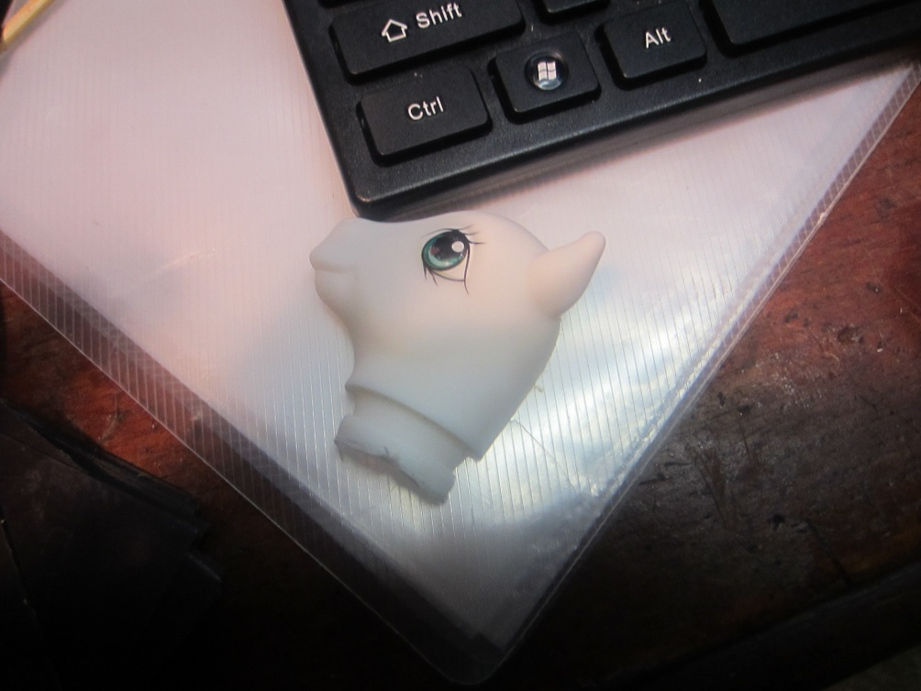
Pull the pony head off, cut it in half, but don’t do that yet. I’ll tell you when.

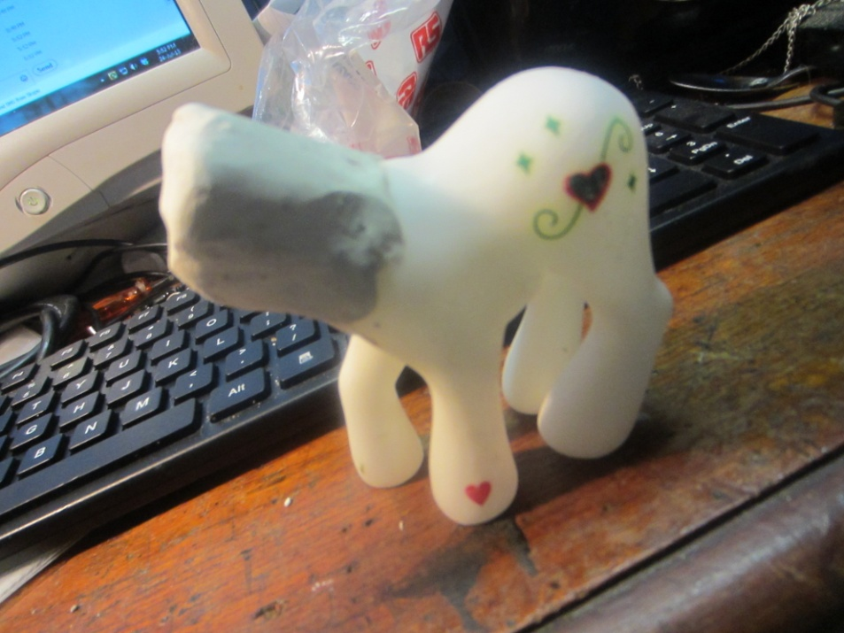
Build the clay into the neck, and build the head and neck shape like you want it to look like. Use the pulled off head as an example. Also I should say you should pull off all the hair, you don’t want your cast to get stuck.
Roll a big ball for the head and a smaller one for the muzzle. Make sure the neck is not too long.

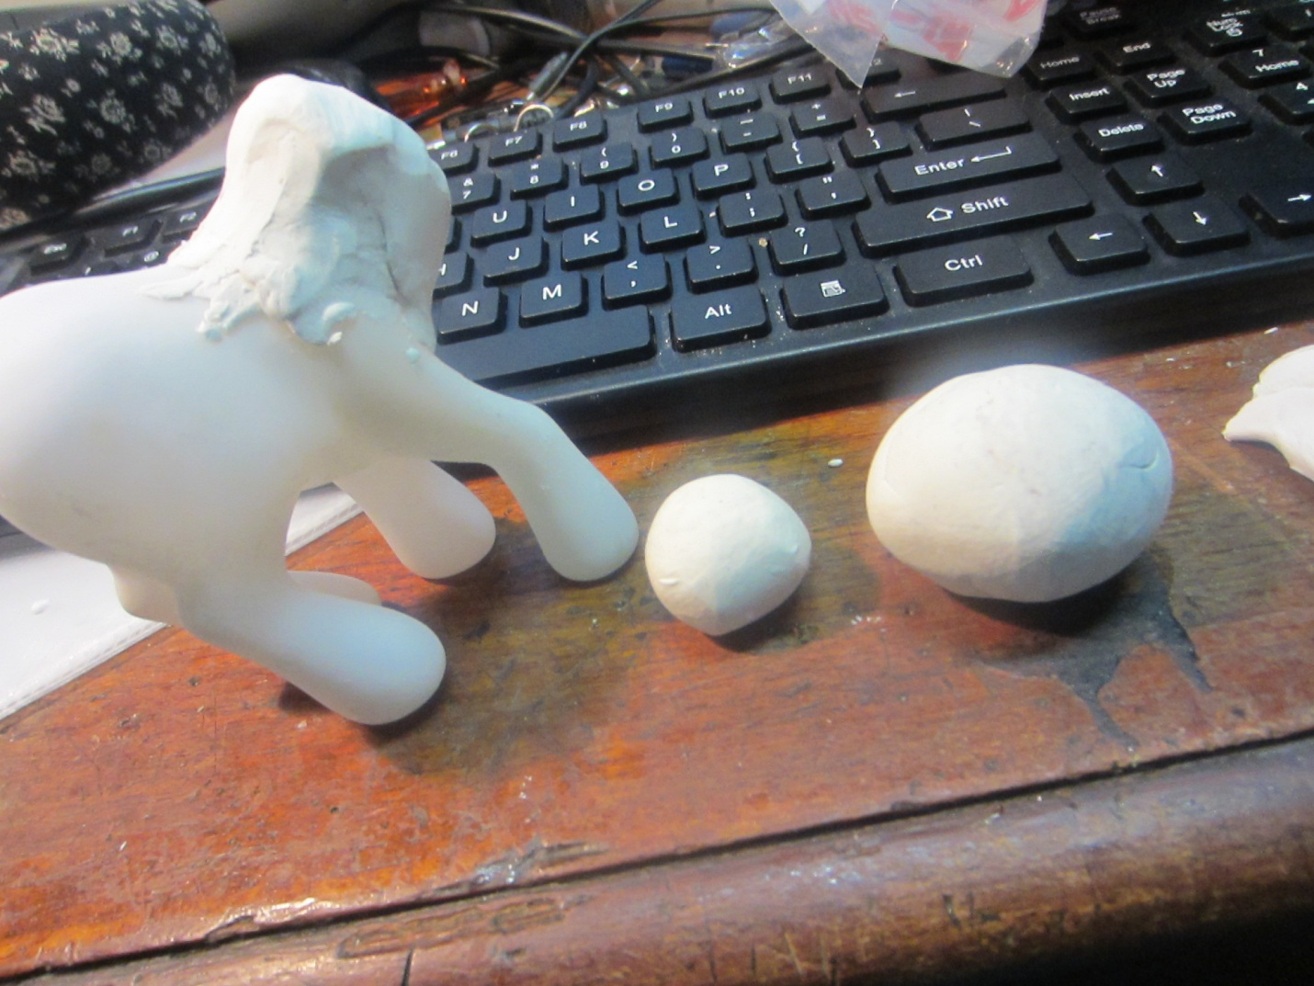

Roll the balls.
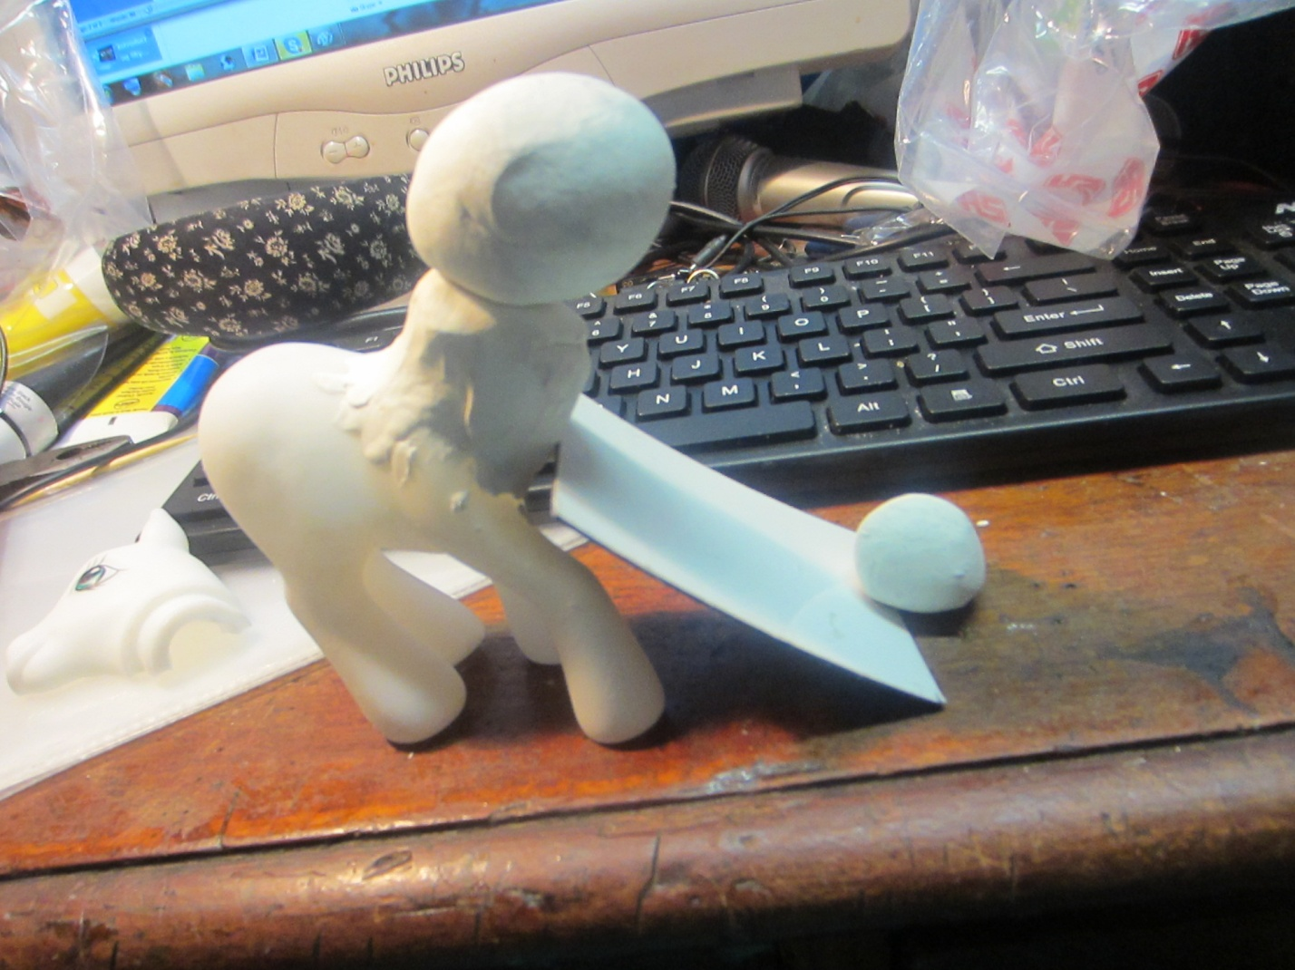

You see the plate, could be plastic aslong as it can be used to prop or cut—not sharp but stump.

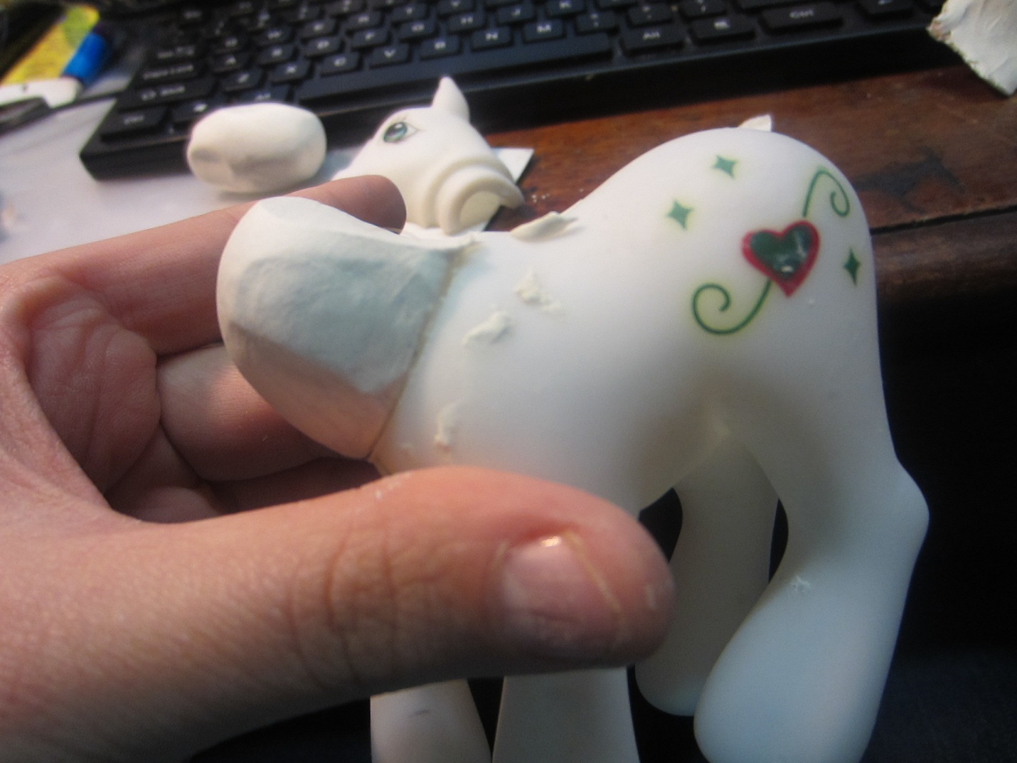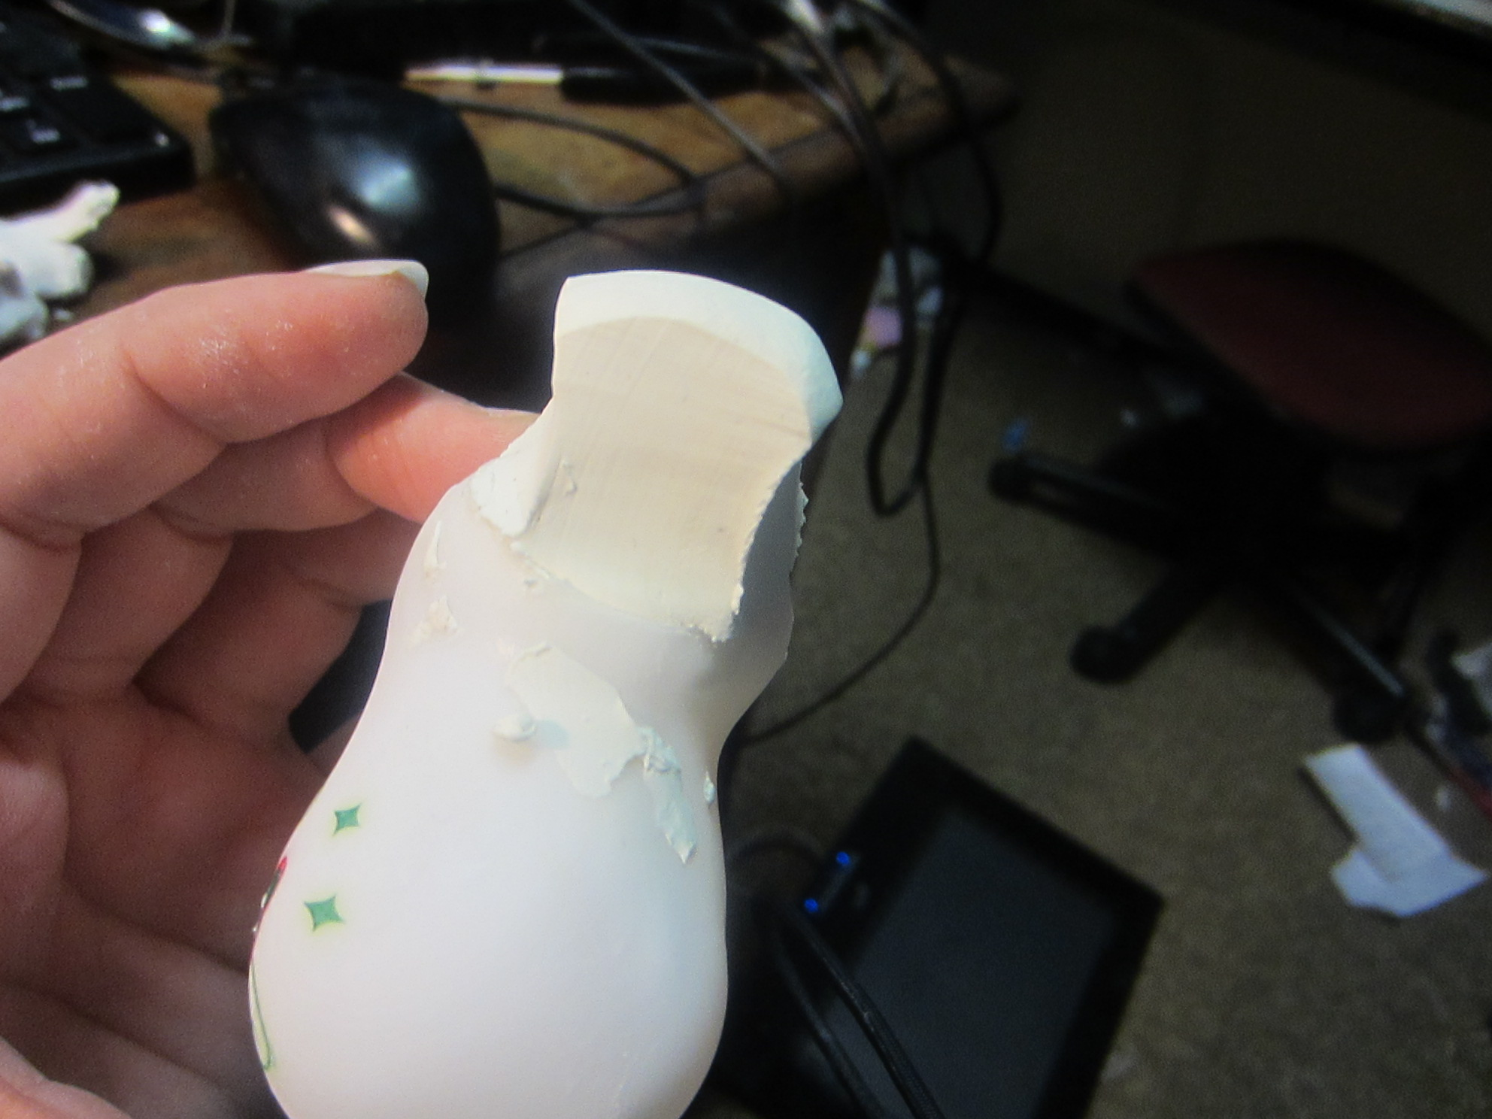

Cut the neck thin.
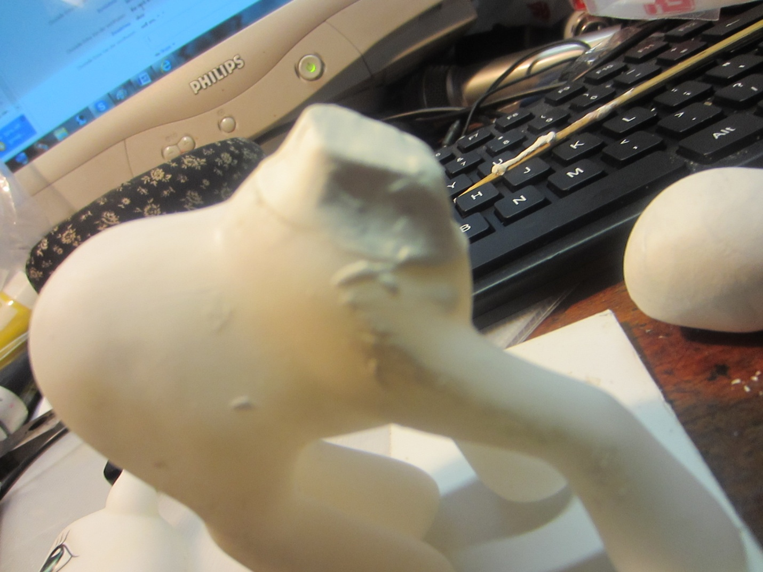
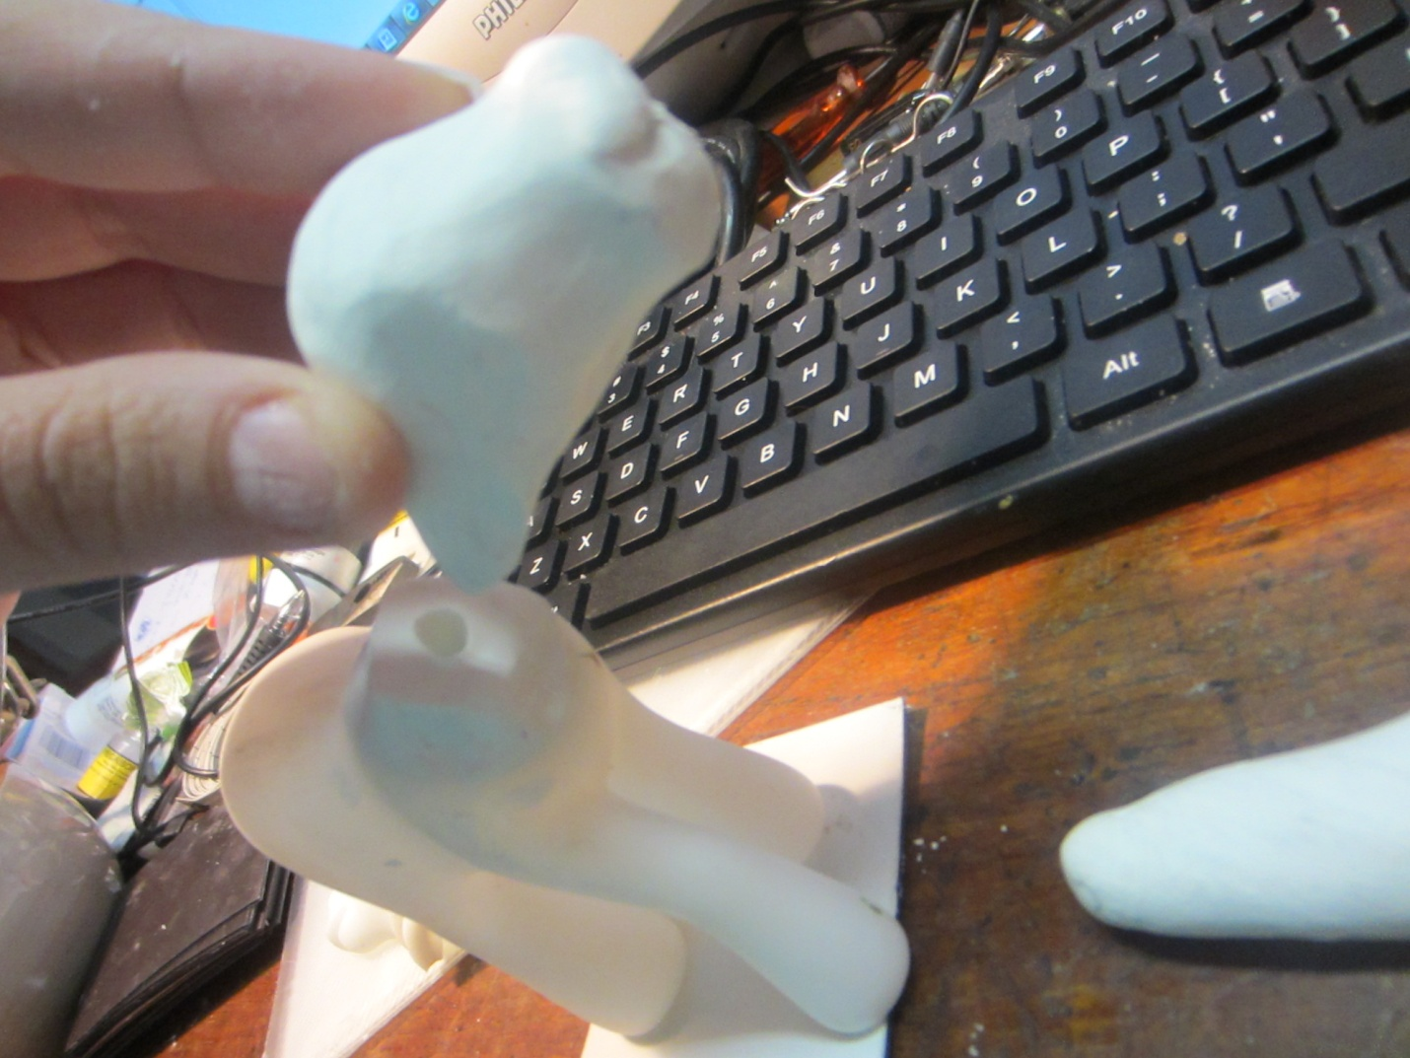

Make a hole to make the neck look normal instead of smudging it and to have wrinkles in it, to make a hole for the tip of the neck.

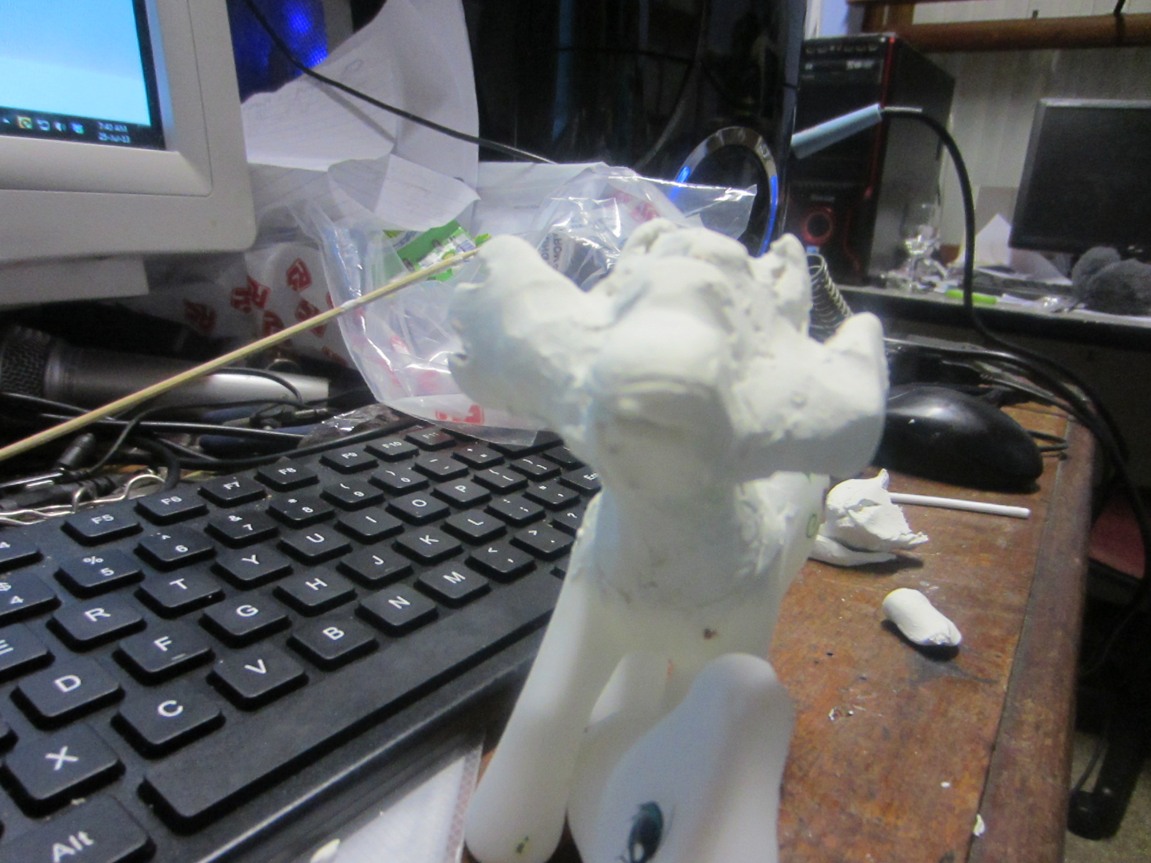

This pony has wings at the sides of his cheaks.

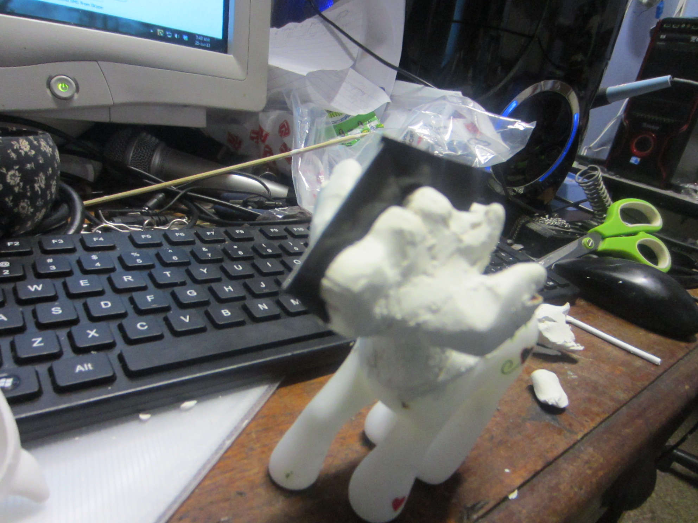
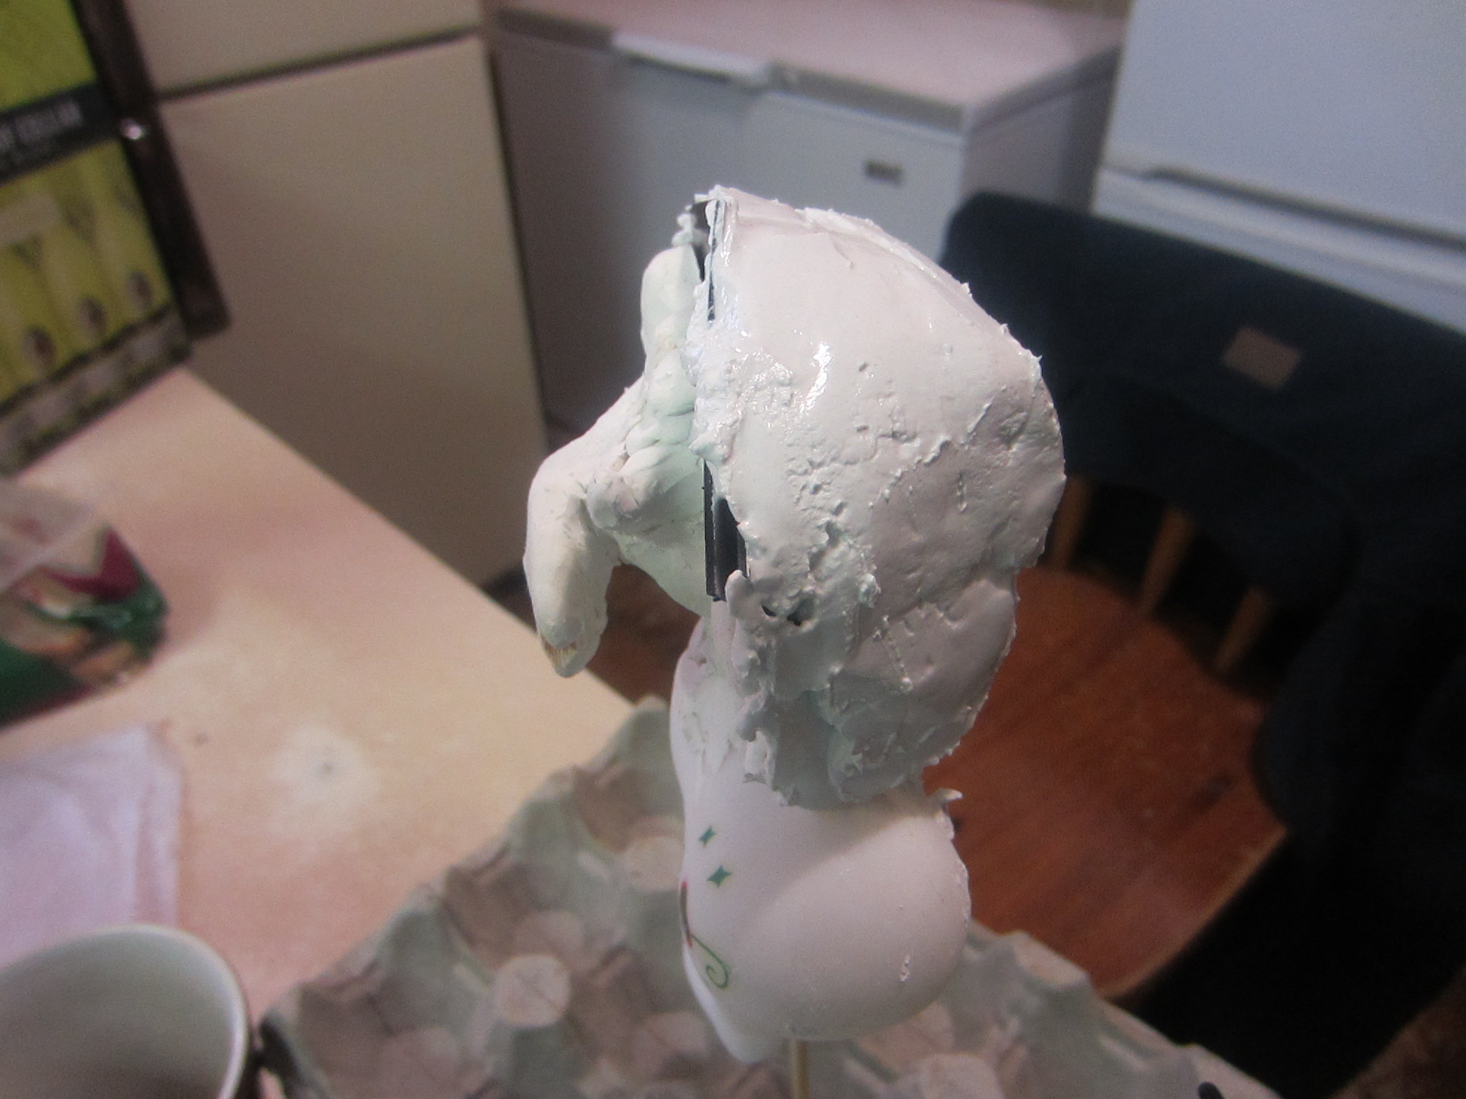

After sculpting you take a stick and stick it through the bottom to the neck so that neck does not fall off. Then mix a plaster of paris after sculpting, make sure you’ve cut the half. Then take the plaster thick, and then put it at the one side. Let it dry and then take the slides out and then do the other side. You’ll have your cast in 3 days.

