“The Rematch”

*An MLP:FiM Fan Fiction by Lucky Star*

Another beautiful day in Ponyville, it seemed, as sunlight streamed through the few clouds that dotted the sky. The day found Applejack, Rarity, Rainbow Dash, Pinkie Pie, Fluttershy, Twilight Sparkle and Applebloom sitting outside Sugar Cube Corner enjoying a pleasant lunch together. They were just laughing at one of Pinkie Pie’s usual jokes.

“So, Applejack,” Twilight said, changing the subject, “are you looking forward to participating in *this* year’s Equestria Rodeo?”

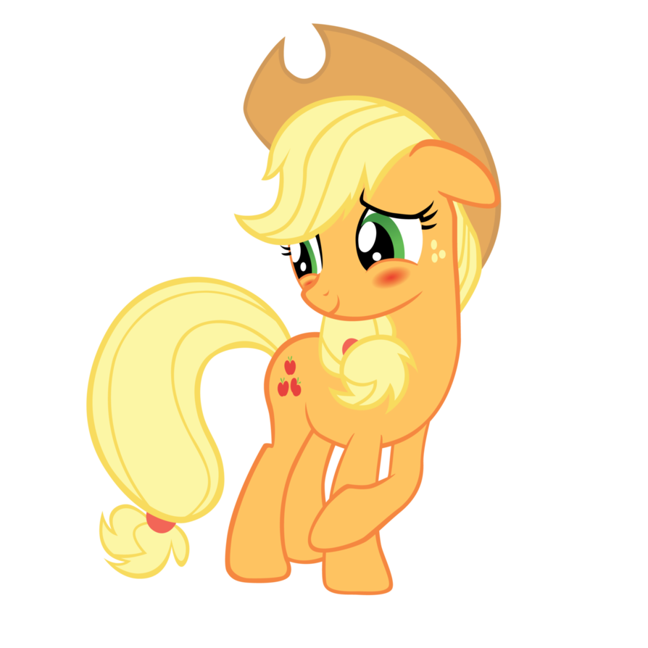 Applejack looked down and blushed slightly. “Well, I’ve been training hard and I reckon I will do a might better this time.”

She grinned sheepishly.

“Oo oo oo!” Applebloom said suddenly, flailing her hooves emphatically. “Especially since THIS year the rodeo is being held in Bridleton! Less ponies will be there because it’s not so big as Canterlot, so you shouldn’t feel any pressure at all when you compete!”

“Not to mention we won’t have to fix town hall again this year,” Rainbow Dash muttered under her breath, rolling her eyes as she sipped her milkshake.

“I don’t know ‘bout that, Applebloom,” Applejack replied, rubbing her mane while ignoring Rainbow’s retort. “The Equestria Rodeo is a huge thing for us earth ponies. I’m guessin’ they’re’ll be plenty a’ ponies there comin’ from near and far, and we’ll definitely see folks like Calamity Mane!”

“Well, that’s great! Because everybody should get a chance to watch the bestest rodeo pony Equestria has ever seen, which ISN’T Calamity Mane… it’s YOU!” Applebloom exclaimed, nearly bouncing off of the wooden bench.

“Ah shucks,” Applejack said, tilting her hat low over her eyes. “I’m glad you think so, little sis.”

“Well, just so long as you don’t go running away from us again,” Rainbow Dash interjected, throwing a hoof around Applejack and rubbing her head with the other - “because I don’t want to have to go chasing you all over Equestria again!”

Applebloom’s eyes enlarged and became glassy as she looked up at Applejack expectantly.

“I reckon you won’t hafto!” Apple jack said quickly, pulling away from Rainbow Dash. “I plan on coming home with some BLUE ribbons this time!” She gave Applebloom a reassuring pat. “Like I said, ‘been training hard and I think I got a really good shot at taking home first in some events, at least!”

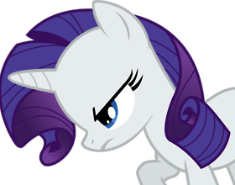 “Yes, DAH-ling!” Rarity interjected, “It was simply AWFUL, getting left behind in a wretched place like Dodge Junction! All the dust and the cactus and the running. We wouldn’t want THAT to happen again, now would we?” She glared pointedly at Rainbow Dash, who averted her eyes and whistled.

Twilight smiled knowingly. “No pressure, AJ – just do your best and most importantly, have fun!”

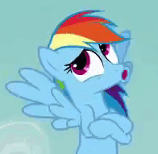“I’m really glad you decided to give it another try,” Fluttershy offered, speaking barely above a whisper. “After the last rodeo, I was afraid you wouldn’t pluck up the courage to try it again!”

A little blue bird, which had been sitting on a branch above the group, glared down angrily at Fluttershy and twittered. The girls glanced up.

“Oh, no offense!” Fluttershy said, her face crestfallen. The bird twittered then flew away.

“We got a sayin’ down at the farm,” Applejack replied, turning her gaze to Fluttershy. “If’n you fall off the horse, you gotta get right back on and try again!”

Pinkie Pie burst into a fit of uncontrollable laughter right at that moment, spitting out her sip of milkshake and falling backward from the wooden bench onto the thick grass while holding her sides. “THAT’S FUNNY!” she gasped emphatically, trying to breathe as she rolled. “Fall off the HORSE! Who would ever want to RIDE A HORSE?”

She continued to laugh and the rest of the ponies looked at each other, shaking their heads.

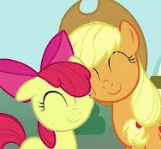 “Well, we all better get packed to go,” Applejack said, standing. “I really appreciate y’all coming with me and Applebloom this time to cheer me on.”

“I’m really looking forward to it! It’ll be fun!” Applebloom said, proudly gazing up at her sister.

“Wouldn’t miss it for the world,” Twilight shouted over Pinkie Pie’s laughter, which seemed to have increased in volume.

They said their goodbyes. As they started toward their residences, respectively, they could still hear Pinkie Pie crowing in laughter, saying, “A HORSE! That’s the silliest thing I’ve EVER heard!”

**[For those of you who like to follow the show format, consider this the point where you would slowly pan out, the screen would fade to black and the MLP:FiM theme begins to play. ☺]**

***

As the train sped through the desert, the Mane Six saw sprawling orchards and fields stretching toward the base of Mustang Mountain. Up ahead was Bridleton - a dusty little desert town that appeared to be a larger version of Dodge Junction. Wooden buildings with traditional western-style edifices lined the streets, punctuated by brick houses and open-air markets. The train pulled to a hissing halt at a nicely constructed plum-colored platform trimmed in white. A large sign across the front of the steeped platform roof read, “Welcome to Bridleton,” also painted white and speckled with dust.

The Mane Six disembarked, talking excitedly about the trip through the San Palomino Desert and the upcoming events. Pinkie Pie carried on about Prickly Pear Funnel Cake, a carnival dessert delicacy originating from Bridleton while waiting for all of Rarity’s trunks to be unloaded by a skinny bell pony.

“And I’m going to buy, like, a million of them!” Pinkie finished, waving her hooves in the air as though she was shoveling cakes into her mouth, then nomming loudly. She licked her lips. “I can smell them already!”

In fact, Pinkie COULD smell them…or, at least, sweet prickly pears: a pale green filly with a violet mane worked a Prickly Pear stand with her father at the end of the platform, selling Prickly Pear Tarts and a whole bushel of tasty treats. Applebloom squealed in excitement at the prospect of inducting a new member into the Cutie Mark Crusaders, but was visibly disappointed when she saw the paddle cactus segment with a prickly pear on the green filly’s hindquarters. Applebloom subconsciously covered her own hindquarter with her tail.

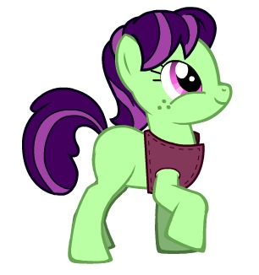The filly’s light fuchsia eyes lit up when she saw the newcomers step off of the train from Ponyville.

“Hello! Would you like to buy some tarts?” the filly asked excitedly in a high squeaky voice.

“Aw,” said Applebloom as the group approached, suddenly losing her shyness. “They look delicious!”

“DELICIOUS?!” Pinkie Pie exclaimed, “They look more than delicious!” She threw a bag of bits on the table. “I would like ten of each please!”

The filly giggled. “You got it!”

“What’syer name?” Applebloom asked as Pinkie Pie stuffed her face.

“Sweet Tarts!” the filly replied, looking up at Applejack. “Are you going to participate in the rodeo tomorrow?”

“Sure am!” said Applejack, puffing her chest proudly and tipping her hat.

“She’s my sister, Applejack!” Applebloom said proudly. “She’s the best rodeo pony in Ponyville!”

“That’s great!” Sweet Tart said. “It’s one of my favorite events. One day, I’m going to be in the rodeo!”

“I’m sure you will,” said Applebloom. “But you’ll have to work VERY hard if you want to be as great as my sister!” She winked.

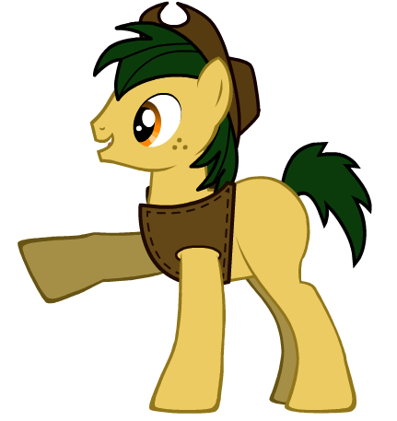 “Oh, I’m sure she’s great,” Sweet Tart said sweetly, “but it’s Lucky Star I want to be like!”

As soon as the filly spoke, Applejack blanched as though she’d been applebucked in the stomach, her eyes widening to the size of dinner plates. Her legs wobbled. “L…Lucky Star? She’s competing this year?”

“Sure is! I hope I get a front seat at the rodeo! I want to see her real close. She’s the best rodeo pony to ever compete from these parts!” Sweet Tart made an attempt at bucking, but fell back on her rump. Her father, a dun-colored colt named Cactus Pete, placed a hoof on her shoulder. He chuckled.

“Now that’s enough, Sweet Tart,” he said, then turned his attention to the girls. “Will that be all?” he asked with a smile.

“Just one more thing,” Twilight said, eying Applejack suspiciously. “Where can we find the Saddleback Inn?”

Cactus Pete pointed down the center road. “Cut left once you get to the clock tower. It’s about four or five doors down from there. The fairgrounds are just over yonder, past the west end of town.”

He tipped his hat and Twilight thanked him, dragging Applejack away by her tail. She had frozen in place, shaking, unable to move, babbling nonsense.

Once they were well down the street, Twilight let go of Applejack’s tail and turned to face her. “AJ, what’s wrong? You look like you’ve seen a ghost!”

Applejack shook her head, snapping out of her stupor. “I… I think I have! I didn’t know Lucky Star was competing again this year!”

“Who’s Lucky Star?” Rainbow Dash asked haughtily, hovering in place and crossing her arms. “And what’s the big deal?”

Applejack huffed, pawing at the dirt with her hoof. “I didn’t tell any y’all ***why*** I came home with so many second and third-place ribbons last year.”

The group looked at each other, then back at Applejack. “And this… Lucky Star had something to do with it?” Twilight asked.

Applejack’s ears flattened and she glared angrily at the horseshoe-shaped scuff in the dirt she had made. “You might say that.”

“Why don’t you tell us over lunch?” Fluttershy suggested. “We’ve travelled a long way and I’ll bet a little food might help.”

The suggestion was met wit a loud groan from Pinkie Pie. She wobbled on her legs, her stomach distended from all the sweets she had eaten almost all at once. Flakes of tart crust and a splatter of prickly pear jam adorned her mouth. “I don’t think I could eat another bite!” She said, dropping to the dusty road, her tongue flopping out of her mouth.

*****

Sitting around a table in a café near the Saddleback Inn, Applejack told the group in detail what had happened in the Equestria Rodeo in Canterlot while the her friends and sister listened attentively.

“Lucky Star is a pegasus who was allowed to compete – apparently, she’s been competing in minor rodeo shows all her life – but only if she binds her wings so’s not to have an advantage over earth ponies. From what I gather, if she ever removes that binding, she’ll be banned from all rodeo competitions forever. But I don’t think that’s right, bound wings or not - the Equestria Rodeo is a chance for *earth ponies* to show off their talents!”

Rainbow Dash’s eyebrows dropped. Fluttershy touched her shoulder, shaking her head. Rainbow Dash sighed under her breath.

Applejack continued. “Well, anyway, she beat me in every category and took home the most blue ribbons I’d ever seen –more than I had won in the rodeos back in Ponyville combined. The only categories she didn’t beat me in were the hay bale toss and the bucking competition. Even then, I only made second place in both those events. Lucky Star won blue in the horseshoe toss, corn-husking, pie making, cattle-roping, whittling – even guitar playing, and that wasn’t even part of the rodeo itself!”

“So, who won hog-tying? I like that competition!” Pinkie Pie asked, suddenly snapping out her food coma.

Applejack blinked. “Uh, I think that was Calamity Mane.”

“He’s awesome!” Rainbow said emphatically. Twilight elbowed her. “Ow! What’d you do that for?!” Rainbow whispered incredulously. Twilight rolled her eyes and looked meaningfully at Applejack. Rainbow understood immediately and settled down, rubbing her elbow.

Applejack rested her head on her hoof and sighed, looking more and more glum as she prattled off her list of defeats. “But the biggest competition she won was the obstacle course. Applebloom will tell you – I trained every day for that competition for almost a whole year. And a pegasus beat me. In fact, she went home the Equestria Rodeo Champeen!””

Rainbow Dash couldn’t hold back any longer. She crossed her arms and threw her head back haughtily. “Well, that’s ‘cuz we’re AWESOME! And fast!”

“And light boned. I KNOW that,” Applejack snapped, thumping the table with her hoof. “But y’all have those air races n’ things… why not leave the earth-type stuff to us earth ponies?”

Twilight stepped in before the two really began to argue. “I am sure there was good reason to let a pegasus compete in the rodeo. And I am sure she trained just as hard as you did Applejack, especially if she has to bind her wings. But look on the bright side… it seems she’s still not as strong as you!”

“I know,” Applejack sighed and slumped in her seat. “And I know I’m just being jealous. But I can’t get past feeling that it just wasn’t right!”

Twilight elbowed Rainbow Dash preemptively before she could retort. Rainbow squealed loudly. “Ow! Now what was THAT for?”

Twilight didn’t answer.

“Huh. It doesn’t matter. Nothin’ I can do ‘bout it now,” Applejack said.

“This doesn’t change change your mind ‘bout the rodeo, does it?” Applebloom looked at her sister with the same large, sad glassy eyes she had back in Ponyville.

“Yes, please tell us it doesn’t change a thing,” Rarity said. “I mean, really - green isn’t your color… or, maybe it is … but, oh, Applejack! Please tell me you didn’t drag me all the way out to this dusty, dreadful place for no reason!”

Applejack looked from Rarity to Applebloom and ruffled her sister’s mane. “No lil’ sis, it doesn’t change my mind ‘bout the rodeo.”

“YAY!” Applebloom shouted.

“Well, I’m glad you’re competing anyway,” Twilight affirmed, raising her glass to Applejack. “You’ve trained hard and I just know you’ll bring home lots of blue ribbons this time!”

They all raised a toast to Applejack.

As they all took deep swallows, Applejack said sarcastically under her breath: “Yeah, I’m sure I will.”

*****

The fairgrounds and wooden coliseum buzzed with activity the following day. Ponies of all varieties visited food stands, played rodeo-themed carnival games, square danced and socialized while waiting for the official start. Applejack and the rest of the Ponyville ponies were standing near the holding area for the competitors. Rarity stood out among the rest (indeed, the rest of the entire town), with a fancy western ensemble that featured an enormous sunhat and rhinestone sunglasses.

Applejack stretched and stomped her hooves, bucking a hay-stuffed sack for practice. Applebloom cheered her on, offering encouragement.

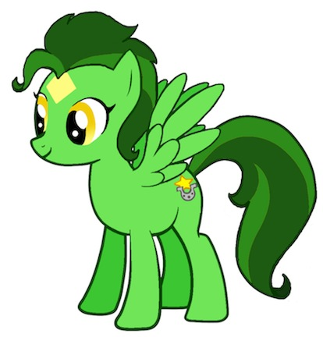 They were talking among themselves when they heard a voice pipe up from the crowd:

“Is that Applejack? Hey… hey Applejack!”

Applejack and the group whipped their heads around to see a bright green pegasus trotting through the crowd toward them. Her short mane and long tail were a few shades darker than her coat, streaked with clover-green. A pale yellow star graced her forehead and her golden eyes flashed with recognition as she approached.

“Applejack! Nice to see you again!” The pegasus stopped short of the group, smiling.

Applejack blinked then scuffed the dirt. “Howdy, Lucky,” she said tersely.

“So YOU’RE Lucky Star, huh?” Rainbow Dash said, zipping over and hovering close to the green pony. She draped her arm around the surprised pegasus. “We’ve heard SO much about you! Isn’t that right, Applejack?”

Applejack scuffed. “Some.”

Twilight glared at Rainbow Dash. Applebloom admired the gold star overlaid with a silver horseshoe on Lucky Star’s rump.

“It’s nice to meet you,” Lucky Star said sweetly, “and I’m glad Applejack remembered me!”

“Of course,” Applejack said sarcastically. “How could I’ve forgotten *you*?”

Lucky Star didn’t seem to notice Applejack’s dour attitude, though in truth, she did. In spite of Applejack’s hostility, Lucky Star went on to praise her talents.

“I tell ya, I’ve never seen a pony throw a hay bale so far in all my life!” Lucky Star said, looking right at Applejack. “I’m lucky if I can get any bales half her distance!”

“That’s ‘cuz my sister is the best there is!” Applebloom said, puffing her chest up.

“Well, maybe this year you can get your hay bale farther than hers!” Rainbow Dash suggested with a haughty sneer. Applejack, Rarity and Twilight glared at her. Fluttershy’s eyes widened. Lucky Star just laughed.

“Somehow, I doubt that!” she said spiritedly, then blushing. “It’s not my best subject.”

“So, what *is* your best subject?” Rainbow continued, pretending to be oblivious toward Applejack’s darkening face. “I hear it’s the obstacle course…”

“OKAY!” Twilight said, stepping between Rainbow Dash and Lucky Star. “You know, I think the rodeo is going to start soon, so we better get Applejack to the main gate! It was lovely to meet you, Lucky Star – and good luck out there!”

“Right,” Lucky Star said, turning toward Applejack. “Good seeing you again! Good luck!”

She trotted off into the crowd.

Applejack glared at Rainbow with clenched teeth, then stomped toward the coliseum gates.

“Rainbow!” Twilight said angrily, turning toward the hovering pegasus. “What’s the matter with you?”

“Hey,.. I can’t help it if Applejack has a problem with pegasi competing!” Rainbow snapped back. “That’s totally uncool of her!”

“Applejack didn’t mean it that way,” Twilight whispered fiercely. “She ‘s just very competitive and still smarting from the last time… I’m sure you can appreciate that!”

“Yeah, and it’s not like I get that mean spirited when I lose!”

Twilight rolled her eyes. “Riiiiiight.”

“Fillies and gentlecolts,” the announcer blared over the speakers set up around town just then. “The first of the Equestria Rodeo competitions will begin in ten minutes! Will all competitors please make their way to the arena!”

“That’s your cue, dah-ling,” Rarity said to Applejack.

“Oh boy! My first Equestria Rodeo!” Applebloom cheered, hopping up and down. Twilight, Fluttershy, Applebloom and Pinkie Pie began making their way toward the spectators’ entrance, but not before Applebloom hugged her sister. “Good luck big sis!”

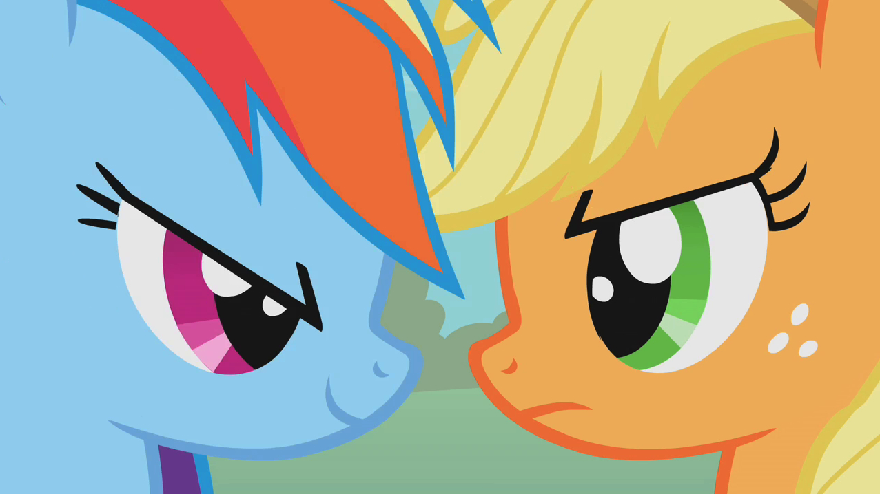 “Thank y’all kindly! I’ll be lookin’ fer ya in the stands!” Applejack said, doing her final stretches.

Rainbow Dash flew slowly by. “Yeah, break a leg out there…” she said slyly, then leaned in close to Applejack, saying: “or not!”

“RAINBOW!” Twilight cried.

“WHAT?!” Rainbow retorted, zipping off to join the group. Applejack glared at Rainbow Dash, gnashing her teeth. Shaking off the anger, she trotted in place for a final time.

“Don’t listen to her… ’t ain’t to big deal. Lucky Star ain’t no big deal, neither. Just do yer best, Applejack. You got this one hay bagged.”

She trotted toward to competitor’s entrance.

*****

“Fillies and gentlecolts! Welcome to the one hundred and twenty third annual Equestria Rodeo!”

The spectators stomped their hooves and cheered.

“The Equestria Rodeo, a long standing tradition for the earth ponies of Equestria, features ponies eager to showcase their strength, speed, agility and stamina! We have a great selection of competitors from all across our fair land…

and here they come now!”

Within the arena, two large arched wooden doors swung open. Two by two, earth ponies of all sizes, shapes and colors trotted in to the dusty ring. The crowd cheered louder, stomping their hooves and swishing their tails in anticipation. Twilight, Rarity, Fluttershy, Rainbow Dash and Pinkie Pie cheered for Applejack as she made her entrance next to a tawny brown colt. The bandstand played a cheery western waltz as the competitors entered.

Applebloom cheered the loudest. “GO APPLEJACK! WOO HOO! THAT’S MY SISTER!”

Applejack swung her head and immediately caught sight of the girls in the stands. She trotted with her head held high and nodded to little Applebloom.

When Lucky Star entered abreast a pale yellow pony, it was clearly obvious that her wings were bound tightly to her flanks.

The competitors, about thirty or so, wound their way around the arena floor, past bales of hay and half-cut barrels, past the lasso rack and around to the front of the grandstand, where Bridleton’s mayor was conducting his duty as master of ceremonies. Several prominent ponies from the town, stood nearby, including the sheriff, who hovered near a stand draped in a white cloth.

“Welcome, everyone!” the mayor said in his deep western drawl. “I see we have an excellent turn out this year – some faces I recognize, and some new!”

The participants stomped and cheered, just as the crowd did.

“As always, each entrant will compete in a number of games and contests, each with its own prize category!” He smiled, gesticulating to a display board decorated with a number of ribbons in various sizes, shapes and colors. “All of this will be counted to determine who will be crowned…”

The sheriff dramatically pulled the drape from the stand, revealing a trophy with a golden lariat atop a spire of rich, deep blue, emblazoned with a golden number one.

“…the Equestria Rodeo Champeen!”

A great acclamation rose from the crowd and the contestants. Applejack’s eyes gleamed when she saw the trophy.

So did Lucky Star’s.

“And now, let the rodeo begin!”

And so the rodeo began. From the beginning, it seemed to be a montage of activity. The contenders raced and roped and jumped and whittled, though from the offset it was very obvious that the competition belonged to Applejack and Lucky Star. Applejack knew her year of training had paid off when she took first in the hay bale toss, as she expected, squeaking past Calamity Mane to take the blue. She also came away with blue in the trick roping, bucking and pie making – however, every win was extremely hard won. What chapped her, and badly, was how easy Lucky Star made everything look. Throughout the rodeo they traded competitive glares.

Lucky Star was not to be outdone. She took blue in the agility-testing barrel race, horseshow toss, pole bending and whittling competition. Blues for other categories went to other participants, but both Applejack and Lucky Star came away with more second and first places than most of the other ponies competing that day.

Exhausted, the competitors threw themselves to the dusty arena floor while the master of ceremonies announced the final event.

“What an amazing show we’ve had today here, folks! We’ve had an impressive display of skill and stamina, but the last and most challenging part of the rodeo is set to begin!”

The crowd of spectators leaned forward in anticipation. Pinkie Pie leaned so far in that she fell on a popcorn and haydog seller in the row of seats below.

“The last, most daring part of the Equestria Rodeo is the Obstacle Course… of…course!” The mayor said, clearing his throat. “And this year is no exception, because the contending ponies will have to run their way through…”

The sheriff again tugged aside a curtain, this time covering an open gate toward the back-left of the grandstand, revealing the entrance to a long, rocky, steep gorge, speckled with gray and black stone.

“…Lodestone Canyon!”

And audible gasp rose from the crowd, and the jaws of the contestants dropped. Applebloom’s eyes nearly popped from her head.

“This year, we’ve added a twist,” the mayor said proudly, as though the idea had come to him alone during the planning for the rodeo. “Along the route, our rodeo officials have set up game stations similar to the events our champions just participated in. In order to complete this obstacle course, each contestant will have to also complete these tasks in order before they can move on to the next. There are five in total: trick-roping, bucking, horseshoes, pole bending and finally, a hay bale toss!”

Applejack was secretly pleased. ‘*Yes! I took blue in three of those competitions. I’ll bet Lucky Star is reeling right now. This’ll be a piece of cake!*’ she thought.

Lucky Star panted, the sweat rolling off her coat. “Oh,” was all she managed to say.

“This is a no-holds barred, get there as quick as you can race to the finish! Once the last pony crosses the finish line, our judges will meet with the event officials and count up ribbons to decide who will be the next Equestria Rodeo Champeen! But for now, there will be a ten minute intermission! Please refill your popcorn and be ready for the last, most challenging event of the rodeo!”

The crowd cheered. Lucky Star made her way over to Applejack.

“Wow!” she said, still panting. “Some competition, huh?”

Applejack regarded her coolly. “Some,” she said.

Lucky Star continued, “Yeah, certainly not like the rodeo in Canterlot… the obstacle course there was pretty straight forward. It was fairly easy if you ask me…”

Applejack visibly darkened. Lucky Star tilted her head, a look of dismay crossing her face.

“You’re not... terribly fond of me, are you?”

Applejack didn’t reply, her eyebrows low over her eyes.

Lucky Star pressed further. “You… you’re not sore because I took home Equestria Champeen last time, are you?”

“Look, Lucky Star,” Applejack cut her off. “I can really appreciate all the hard work you’ve put in to this, but I feel that some things are best left to us *earth ponies*, ya know what I’m sayin’?”

Lucky Star waited a hitch, then her face completely fell. Her surprise was replaced by a sudden anger.

“So, you think a pegasus shouldn’t compete in an *earth pony* rodeo, huh?” Lucky Star sneered. “Well, let me tell you… I worked pretty hard to get here, to even win last year… especially since I was competing against ponies like Wild Bull Hickok, Annie Oatley and Calamity Mane…”

“Like I ***said***,” Applejack interrupted. “I ***know*** you worked hard. We all did. But I think you have an unfair advantage… being a pegasus an’ all!”

“It’s not like I can fly,” Lucky Star said, stamping a hoof. “I have to bind my wings – I can’t use them or I’ll be disqualified. PERMENANTLY.”

“No, but it still ain’t right. Now if you’ll ‘scuse me, I gotta get ready for the obstacle course!” Applejack stomped off in a huff.

“Fine! You do that!” Lucky Star called after her. “But what’s unfair around here is YOUR attitude!”

Having watched from the stands, Twilight looked at her friends, her face crestfallen with worry.

“Really,” Rarity said, flipping her mane. “Green is definitely NOT Applejack’s color!”

*****

The starting gun was fired. The obstacle course began!

The contestants bolted through the arena gate and up the steep path to the entrance of the Lodestone Canyon. It was a stampede, with ponies jostling and pushing each other for any kind of advantage on the narrow path. Dust kicked up and slid. One pony tripped over a rock and took out five or six ponies with him. The rest continued up the trail, leaping rolling tumbleweeds and a few crossbars placed there for the course. Soon, packs began to form. Lucky Star and Applejack lead off with four or five of the big names in the Equestria Rodeo, while the rest of the ponies slowly fell behind.

They rounded a bend and came to the event: trick roping. The goal was to rope five cans from an old fence railing. Applejack snatched up a lasso and pulled a great many down. Lucky Star had trouble.

“Eat my dust, Lucky Star!” Applejack goaded, galloping on to the next event. Lucky Star fell behind Wild Bull Hickock.

*‘Yes!’* Applejack thought. *‘This’ll be easy!’*

The next was bucking, another of Applejack’s best talents. She breezed through the event and continued on. Lucky Star was right on her hooves, though behind almost a half a minute.

As she sped along the ridge, following dangerous switch-backs and weaving through intentionally placed stakes, Applejack found herself being distracted by thoughts of beating Lucky Star to the finish line. More than once she almost slipped or ran off the trail, but always caught herself in time. Sweat poured down her face as she near the horseshoe tossing station.

Her troubles began with this event. She was so nervous about winning she kept missing the target, giving Lucky Star and the pack time to gain on her. Lucky Star showed up, dusty and sweating, but picked up her five horseshoes and looped them over the metal stake with ease.

She stuck her tongue out at Applejack and bolted down the trail. Applejack growled, tossing her last two horseshoes at the same time – and looping them perfectly.

“Yes!” she said, then tore down the path after Lucky Star. She followed Lucky Star’s dust trail until they came to the pole-bending staging area.

Lucky Star quickly snatched up a rope and wove her way between the posts expertly, her agility and speed clearly visible despite her bound wings. Applejack performed with as much speed, but bounced off two of the eight poles, knocking seconds off her run. Lucky Star was already ahead on the path when she finished.

The rest of the pack didn’t matter. It was now all Lucky Star and Applejack.

*‘It’s ok she’s ahead,’* Applejack thought to herself. *‘The last event is the hay bale toss. There’s no way she’ll beat me in that!’*

Indeed, Lucky Star arrived at the hay bale toss and had difficulty picking one up. Applejack, however, snatched a hay bale’s rope in her teeth and, spinning wildly, let the hay bale fly far beyond the required distance – in fact, it sailed right over the edge of the canyon. The officials “ooo-ed”, noting the distance on their clipboards.

Lucky Star look worriedly at her hay bale, still clenching the rope in her teeth, when Applejack ran past. “See ya at the finish line, Lucky Star!” she crowed.

Applejack smiled broadly and kicked up her heels as she sprinted down the dusty trail. *‘Yes, yes, yes! I’m gonna win THIS year! I’m comin’ home the Equestria Rodeo Champeen!’*

She opened her eyes just in time to see the sharp hairpin turn right in front of her.

“WUH OH!” she cried!

She tried to brake herself, sliding in the dirt and gravel right over the edge of the canyon! She flailed her hooves and closed her eyes, crying out as the expansive valley floor opened way, WAY down beneath her!

“WAAAAAAAAAAAHHHH – oof!”

Applejack opened her eyes, finding herself hanging on to an old dead tree growing out from the side of the canyon. An eagle called in the distance. She gulped.

“Whew!” she said, sweat rolling down her brow. She tried to pull herself, but the tree creaked… then began to pull away from the canyon side.

“Oh no!” Applejack said, looking down again. Yes, it WAS a long way down.

Suddenly, she heard the thundering of hooves above her. She looked up to see a cloud of dust coming down the trail.

“Hey! HEY UP THERE! HELP!” she called. Unfortunately, the loud clopping of hooves drowned out her call for help. The ponies passed her by, running around the switchback and back toward the arena. As they passed, the heavy hoof falls caused the tree to pull even further out of the crumbling earth.

“HELP!” Applejack cried again. The tree creaked more.

Applejack’s lip wobbled. Fear crept into her mind. It was a long way down, after all… too long of a way down.

Suddenly, she heard the sound of hoof beats… this time, from only one pony. Applejack sucked in a huge breath of air and yelled as loud as she could: “HELP!”

The hoof beats stopped. “Oh, thank goodness!” Applejack said, relieved. She heard trotting and a face appeared over the edge of the canyon.

It was Lucky Star. Of course it had to be Lucky Star.

*‘How humiliating!’* Applejack thought as she cringed. *‘Why did she have to stop? Not only is she better than me, now she sees me all messed up like this. Oh, why did this happen?’*

Lucky Star’s eyes widened. “Applejack?! How did… what are you doing down there?!”

The tree creaked and snapped a little. Applejack cried out and held on tighter.

“I slipped off the trail!” she cried, looking up at Lucky Star. “I can’t pull myself up… you have to help me!”

For a brief moment, Lucky Star was conflicted. Applejack had been a total jerk to her since they had seen each other earlier in the day. But it only lasted a moment. Applejack’s life was in danger!

Lucky Star tried to think. The tree was a good fifteen feet or so down the side of the canyon. There were hardly any footholds and besides, Applejack was hanging a good ten feet out on the end of the old tree. Lucky Star looked around, trotting quickly in place in her nervousness.

Suddenly, in the distance, the sound of more hoof beats filtered through the dust.

“Someone’s coming!” Lucky Star called out to Applejack. Lucky Star galloped to the side of the trail and watched as a large pack of ponies came running up. The sound of their hooves reverberated off the canyon walls.

“HEL…” Lucky Star began, waving her hooves. The pack ran right past her, throwing her into a spin. She fell on her rump in the dirt, her head spinning.

“Well?!” Applejack called up.

Lucky Star stood, shook her head, and watched the cloud of dust behind the other ponies fade into the distance.

“It’s no good! They didn’t hear me!” Lucky Star shouted, running quickly in place again. “I can run back and get the officials and some rope…”

The tree groaned and jostled again. Applejack closed her eyes and cried out. Luckily, the tree still hadn’t fallen, but it was only a matter of moments. Applejack started to panic, the distance beneath her causing her to go into a dizzy spell. How was Lucky Star going to run to the officials and back in time? The tree was about to collapse! She was going to fall a LONG way down, and it wasn’t like Applejack could fly…

Applejack’s eyes snapped open. That was it! FLY!

“There’s no time! You gotta fly down here and pull me up!”

“Fly?!” Lucky Star exclaimed. She backed away from the edge of the cliff as thought she were backing away from a physical manifestation of the idea, the thought of heavy hay bales crossing her mind. Applejack must weigh about as much as a small hay bale, and even they were a challenge for the light-boned Pegasus.

“I don’t think I can carry you! Lifting things is not my strong point!”

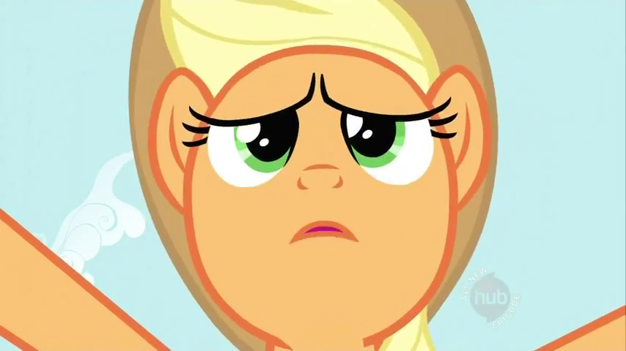 “Yes, you can!” Applejack said beseechingly. “You have to! This tree ain’t gonna last much longer!”

“But…” Lucky Star began, nervously stepping back from the cliff.

“No buts!” Applejack said, then sighed. “I’ve watched you… the way you compete, the way you’re able to do things. You’re stronger than you think… just as strong as any earth pony! I’m sorry I said those things before… about how you shouldn’t compete. I don’t think it was an accident that you’re the one who stopped to help me, because you’re the best pony for the job. And I know… I KNOW… you can do it!”

Lucky Star was transfixed on Applejack’s face. Her soliloquy ringed of nothing but honesty, as did her eyes. Lucky Star, though still nervous about her ability to lift Applejack, no longer doubted that she should try.

She reached around to her side and, using her teeth, tore the cloth binding her wings, knowing full well this meant she could never compete in a rodeo again. She threw her wings wide and flapped them to stretch.

The tree snapped. Applejack fell.

“WHOOOOOOOAAAAAAAAAAAAAA……..!”

Lucky Star dove off the side of the cliff.

*****

“Where’s Applejack?!” Applebloom said emphatically, her eyes glued to the finish line. Several ponies had crossed it and were collapsed on the ground again, panting from exhaustion. Applebloom’s joy had quickly descended into worry when her big sister failed to cross with the leading pack.

“I don’t know, Applebloom.” Twilight said worriedly, patting the foal’s shoulder. “I’m sure she’s alright.”

“I hope something dreadful hasn’t happened to her!” Rarity said.

Even Rainbow Dash was worried. “I’m sure nothing bad has happened… she… she might have gotten lost on the trail!”

Then the last of the ponies crossed the finish line. With Applejack still not among them, the Ponyville girls’ concern went sky high. Rainbow Dash blasted straight up off her seat.

“This is NOT good!” she said, gesturing to the others. “We’ve got to go look for her!”

“What if she got bit by a rattlesnake? Or carried off by a hawk?!” Applebloom cried, verging on tears.

“Now, now,” Twilight said. “I’m sure nothing of that sort has happened. I agree with Rainbow. We should definitely go talk to the rodeo officials and see if we can…”

“THERE SHE IS!” Applebloom cried, zipping down the bleachers to the arena floor. She ran across the dusty ring and practically bowled Applejack over, who laughed and cuddled with her little sister.

Applejack gently pushed Applebloom off and stood up. Bringing up the rear was Lucky Star, her wings folded tightly to her sides, her expression downcast, but relieved as well. Both of them were dusty and disheveled. Closely behind them, the rodeo officials came trotting in, talking excitedly among themselves.

“What happened? I was so worried about you!” Applebloom cried.

“I let my pride get in the way,” Applejack sighed, looking at her friends. “When I was in the lead, I could think of nothin’ but beatin’ Lucky Star and redeeming myself from the last rodeo. But in the end I wound up falling off the trail. Why, if it weren’t for Lucky Star here, I would’ve been seriously hurt!” Applejack put a hoof around Lucky Star’s shoulders. “I tell you, I’ve never been so glad to see wings in all my life!”

Rainbow Dash snorted.

Lucky Star blushed and scuffed the dirt. “Well, I wouldn’t have been able to catch you had you not told me I could do it.”

“Well, I knew you could,” Applejack said, “’cuz you’re one of the finest rodeo ponies I’ve ever seen.”

Rainbow Dash huffed and scuffed the dirt. “And I’m sorry I egged you guys on. I’m just glad you see the benefit to having a pegasus around, AJ!”

Applejack rolled her eyes.

“Well, I’m glad you all could put aside your differences and learn to appreciate one another,” Twilight began.

“LUCKY STAR!” a voice boomed, interrupting. Lucky Star cringed. The girls turned and saw the judges trotting over with angry expressions. Lucky Star lowered her head and took a step back.

“Your wings are not bound! You know the rule – no flying in the rodeo!” the male judge cried. “Unfortunately, because you’ve broken the rules and taken off your bindings, you must immediately return all of your ribbons and you are hereby disbarred from competing in any rodeo anywhere in Equestria EVER again!”

“Now wait a second!” Applejack interrupted, stepping between Lucky Star and the judges. “Lucky Star didn’t use her wings in the competition! She used her wings to save me when I fell off the trail!’

“It’s true!” one of the officials said, stepping up. “As we were heading back, we saw Lucky Star fly down into the canyon and come out carrying Applejack! And we can all say that we didn’t see her use her wings at any other time during the competition.”

“Yeah, she’s a hero!” another vouched.

The judges looked at each other, then trotted off with the officials to speak among themselves. A few moments later, the lead judge returned. He cleared his throat.

“Well, it seems we were hasty in our judgment. You can continue to compete in rodeo. Just be mindful that except in such unusual circumstances, wings are forbidden in the rodeo.”

Lucky Star stood tall. “Yes, sir!” she said.

The judges nodded, then trotted off.

Lucky Star and Applejack looked at each other, then laughed.

*****

Dear Princess Celestia,

I’ve learned that it’s easy to get carried away when you really want something, and badly. It’s also really easy to be jealous of those who make the things you love to do seem so easy, especially after you’ve worked really hard to do better at them. But just because they might have more talent, it doesn’t make your own any less special.

I’ve also learned that it’s better not to judge people by their differences; but rather, by their dedication and talent. Besides, you never know when those differences might just come in handy.

I’m also happy to report that this year’s award for Equestria Rodeo Champeen was a tie. I can think of no better pony to share that title with than Lucky Star of Bridleton.

Yours truly, your loyal subject –

 ~Applejack