Someone know what’s gonna happend on 21 april 2012 ?

A new Sabrina Online? Nope!

Vote for your president? Nope!

A good reason to lock yourself in your room and fake your death? Hell yeah!

This will happened:

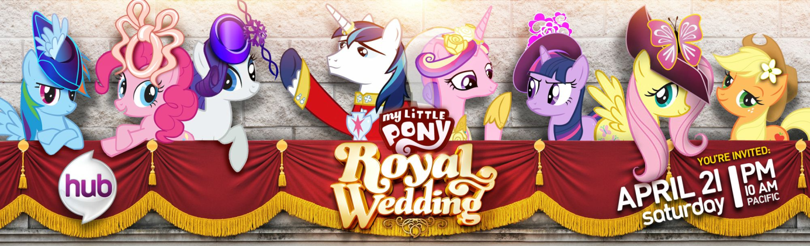

The last episode of the second season of My Little Pony: Friendship is magic will be released.

No, no, no, don’t leave this article now, April fool day is over and I’m serious.

Even if, for a lot of peoples, the little ponies are nothing but little girl’s toys, it’s now an internet phenomenon far from the audience first targeted by the show.

\*History class on\*

My Little Pony: Friendship is magic the third series is on the web channel “HUB” since 10 October 2010.

Its apparition created a debate in the Blog Cartoon Brew with the article of 19 October, complaining about the fact that the animated series was only used to seal toys.

The debate made a snowball effect while reaching 4chan.



For those who don’t know, 4chan is the largest picture blog in the internet. It has the reputation to be a real “melting pot” of the web’s culture. Every events and debates ends up in 4chan where they can be illustrated, debated, or making fun of. The website also has a bad reputation due to its 18 and over section which I won’t talk about.

Logically, the contact between ponies fairy tales and the most diverse (and crazy) community of the web, should have ended in an explosion of bad jokes.

But when we are talking about the internet, and even more about 4chan, the logical arguments are not valid (they are crazy about pokemon and Nyan cat after all).



The debate about animated series was quickly forgotten when the “/b/tards” a part of 4chan users, began to post images of ponies. The “bronies” made they appearance in this moment.

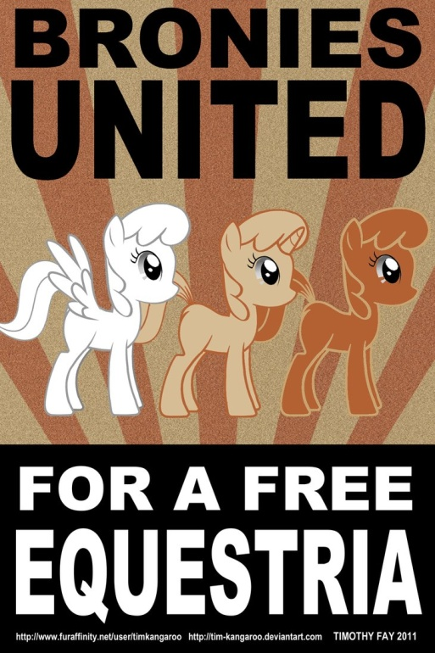

There were also bad reactions, banishment, and the creation of websites as Equestria Daily or Pony chan.

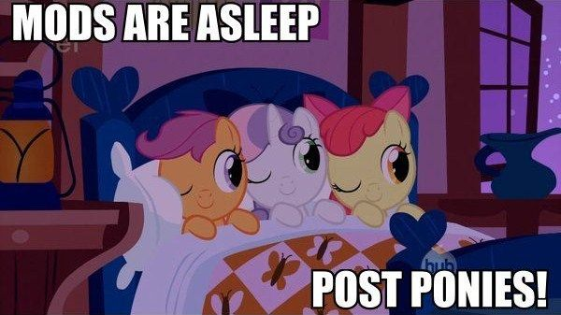

\*History class of\*

Today the “bronies”, the adult fan of the series, are present in their own sites but also in Deviant Art or Youtube where they creates pictures, animations, videos, fanfictions, remix, original musics, and video games.

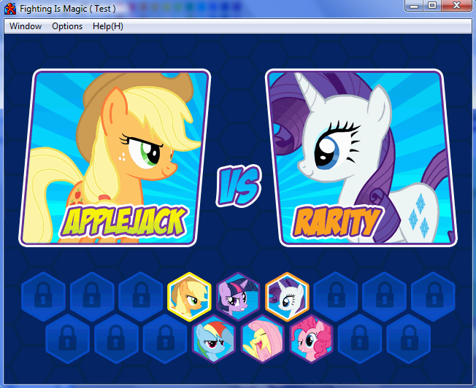

The series’ producers are aware of the community, making reappeared their favorite characters, and making a lot of references about cinema, music, or video games (hard to see for a little girl).

The promotion clip, “equestrian girl” directly name the bronies, and the producer, Lauren Faust, always pay attention to the community.

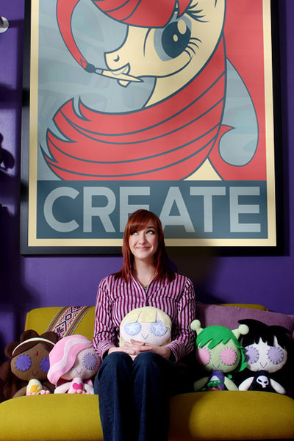

And because this subject is even larger than the previous one, I’m not going to write one but a series of articles.