Recent edit: this was made in mid-April of 2014 when I was still quite new to the fandom. Take that in mind, if something may strike you as naïve in this essay. I still do like what I made, but, with the now newfound larger extent of knowledge I have of the ponies and the fandom at large, I did see it fit to make comments, pointing out what I *now* see as possible errs or blunders in my old logic. Keep your hands & feet inside the vehicle at all times. You may now proceed to read.

~ Miles, on September 5 & 6, 2014  
  
--- comments will appear in this same red color ---  
--- hints of an error in continuation [on my part] (that I just now realized) in this blue color ---

(From mid-April, 2014):

Determining the age of the MLP:FIM ponies:  
Comparing and Contrasting evidence found in the show itself and from multiple internet sources

First and foremost,

DISCLAIMER part one: The age of the ponies has never been truly *officially* revealed, and the reason for this ought to be quite obvious – although there is such a large brony fan-base, quite frankly, the show was originally made for children, and thus kids really don’t care as much as adults as to how old the ponies are. Therefore, Hasbro and the makers of the show had no obligation to, one, figure amongst themselves how old they are, two, make such these ages publicly and officially revealed, and three, because of all the aforementioned reasons, they also probably just didn’t think it was all that important anyway.

DISCLAIMER part two: Despite all of the above, bronies love to speculate on the ponies’ ages and thus there have been many good points made, even some actual studies have been done, however some of the sources contradict each other. Furthermore, what makes my speculation any more or less valid? Nothing. I’m just another fellow brony. BUT, take in mind that this research of mine has included the research of others, ergo that’s why this is using comparing and contrasting to make what I believe to be a very informed guess of the ponies’ ages. By the way, if you even cared enough to read my disclaimers, kudos, go have yourself a cookie.

Introduction

The ages of the Mane Six ponies have been speculated numerous times by bronies and whoever else, but most speculators have not taken care enough to provide accurate foundations for their guesses. The purpose of this specific study is to combine some implied and understood factors of the differences between the Equestrian world and the real world (including comparing humans to real ponies, and then to the Mane Six, and possibly others as well). Then, to have more informed estimates, rather than purely unscientific speculations, this study will include a short explanation of how the time in real life and the time in Equestria are quite similar, if not almost equivalent. Also, an explanation of how Equestrian ponies’ age compared to humans and to real life ponies/horses will be included.

Time

I’ll keep this short, simple, and to the point. Equestrian Time (ET) and Universal time (UT)/International Standard 8601 (ISO 8601) (real world time) are basically identical. The evidence for this exists in the dialogue of the show; the characters blatantly use conventions of real world time to describe events. Despite the fact that Equestria defines their days by rising and setting of the sun and moon, rather than by rotation of the Earth, human’s obviously use the convention of day and night which is also defined by the sunrise and sunset. Then, they also use the human conventions of years, months, weeks, days, hours, minutes, and seconds. It should therefore be safe to assume that Equestrian Time is basically equivalent to time in real life.

Age Equivalencies of [Equestrian] Ponies, Humans, and [Real] Ponies/Horses

This can be somewhat controversial because, in a sense, these age equivalencies are so important that defining the age of the ponies relies on them. However, even though most would agree with putting that much importance on this issue, I feel that the creators of the show didn’t place so much importance on this due to the fact that they care more about a represented mental age than an actual age. Thus, instead of speculating about the differences and similarities, I will just state the facts about humans and real ponies/horses, and go from there.

Humans (based on a simple common perception only):   
Baby = 0 – 1   
Toddler = 2 – 5   
Child = 6 – 9   
Preteen/Tween = 10 – 12  
Teenager = 13 – 19  
Young adult (overlapping with teenager) = 18 – 30  
Middle aged adult = 31 – 50  
Elder adult = 51 – 61  
Senior adult = 62+

Horses (based on true and defined stages of horses):  
0 to less than 1 = Foal  
1 to less than 4 = Filly/Colt  
4 and older = Mare/Stallion

So what about Equestrian ponies? Well, they talk like humans, they do human things, and they use human time… So, based on the assumption that their age is probably more truthfully depicted by their mentalities, actions, job/career/studies, etc., then it seems that their ages ought to be defined the human way. Why? Because converting a halfway between real horses, humans, and Equestrian ponies is just ridiculous, that’s why. Sources that do just that are those who say that the ponies are preteens. Now does that seem plausible when obviously the ponies are depicted as old enough to live on their own in Ponyville, have jobs, and [some] have younger sisters (hence the CMCs) whose age discrepancies as compared to the Mane 6 are obviously depicted as at least older than toddlers, but not yet teens? Uh, the answer to that is NO that’s just not plausible. The Mane Six are not *that* young. Onward we go…

So Then How Old Are They!?

Wow such language! Haha, just kidding. Well now that we’ve gotten all the previous info out of the way, we can look to comparing the ages of the Mane Six amongst themselves. The best episode to do just that would be “Cutie Mark Chronicles” because we see the ponies in the SAME time period when they were younger, since we know that Rainbow Dash’s Sonic Rainboom helped all the Mane Six in getting their Cutie Marks. Take a look at this picture taken from screenshots of the episode (source: <http://mlpforums.com/blog/268/entry-5526-how-old-are-the-mane-6/>)

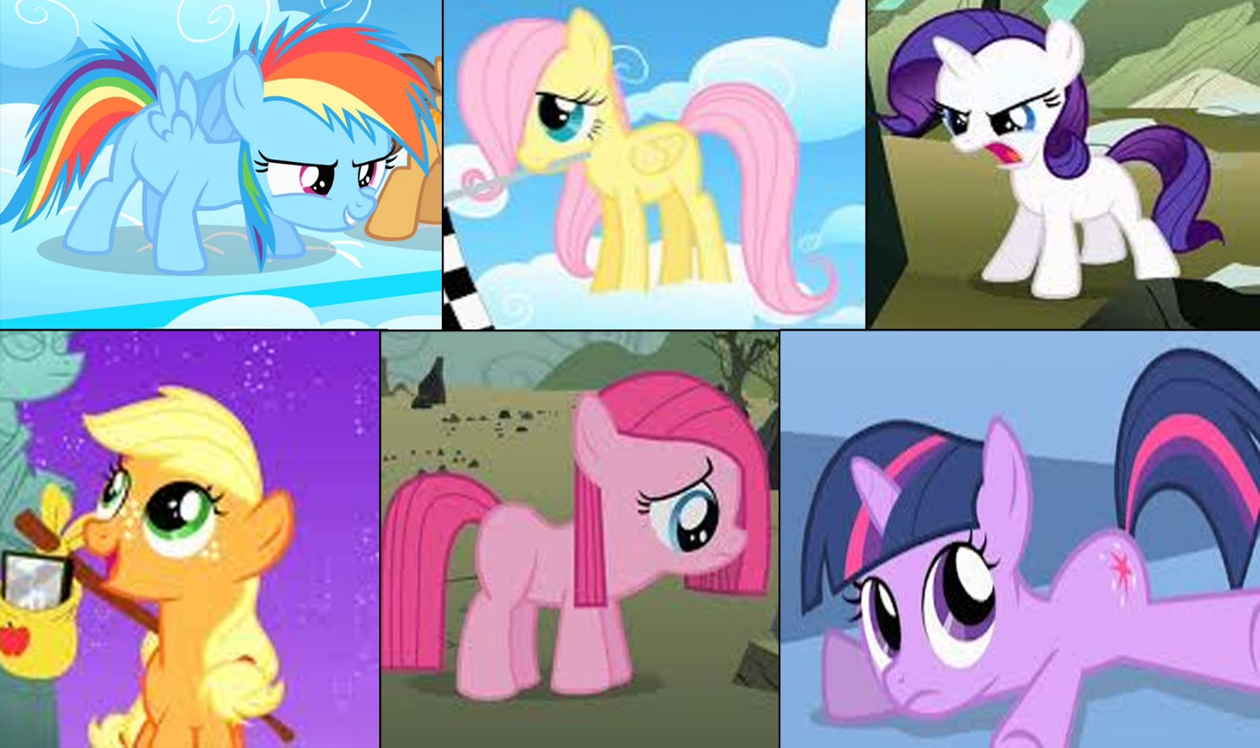

Before going further with the above, take in mind:

Fluttershy specifically stated being a year older than Pinkie Pie.  
Applejack had been working at Sweet Apple Acres since before she even had her cutie mark.  
Rarity was interested in designing since before she had her’s, too.  
Fluttershy and Rainbow Dash grew up in Cloudsdale; Applejack and Rarity grew up in Ponyville; Pinkie Pie grew up away from Ponyville, but no apparent reason was stated as to how she ended up going to Ponyville; Twilight Sparkle grew up in Canterlot (I think), but more importantly, she is a prodigy – she is very intelligent for her age, as well as having been very skilled in magic at a young age. Oh, and Twilight is Princess Celestia’s special student.

Now let’s think about their positions in Ponyville like jobs, as well as their depicted maturity levels, wisdom, and capabilities. Applejack and Rarity seem to have the most life experience as depicted by the aforementioned traits. A.J. is inarguably an experienced farmer, and has displayed that she is capable of taking on much responsibility. Rarity owns her own business. For these reasons alone, it should be safe to assume they are the older two ponies of the Mane Six. Then, we know Fluttershy is a year older than Pinkie Pie, also she is pretty tall compared to the others in the picture above (of the young version of the ponies). Then, the harder part comes – placing the relative age differences of the younger ponies. The reasons I think Pinkie Pie, Rainbow Dash, and Twilight Sparkle are younger follow: Twilight came to Ponyville as a student, and stayed a student for pretty much all the while up until she became an alicorn. Due to this, and since Rainbow Dash and Fluttershy were in the same class, and that we know Pinkie Pie is a year younger than Fluttershy, we can safely assume that the youngest two ponies are therefore Pinkie Pie and Twilight.

At this stage we have this: The elder two are Applejack and Rarity; the middle two are Rainbow Dash and Fluttershy, and the younger two are Pinkie Pie and Twilight. To be able to specifically place the eldest to the youngest in order of 1 being the eldest and 6 being the youngest, we need to look a little closer at hints made in the episodes. Let’s start with this not so subtle Easter Egg…  
(Source: <http://scifi.stackexchange.com/questions/6699/pony-ages-in-my-little-pony-friendship-is-magic>)

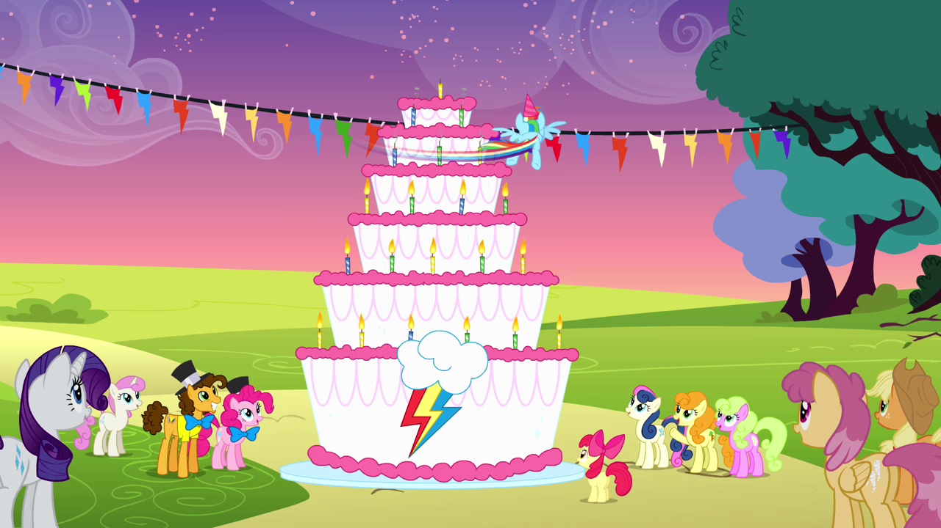

Yes, that is Rainbow Dash’s birthday/anniversary cake. If the assumption is made that candles on a cake are implied birthday candles, then the count is 21. Some say ‘but you can’t see the other side’ – but seriously, do you think such an obvious candle depiction like this wasn’t done to purposely indicate Rainbow Dash’s age? Some might disagree, but I think this is enough to indicate that Rainbow Dash really is 21. And honestly that seems pretty fitting.

\*Since Fluttershy and Rainbow Dash were in the same class, they should be nearly the same age, however due to Rainbow Dash being a weather pony and Fluttershy not really having a job so much as just taking care of animals, it would seem like Rainbow Dash is older than Fluttershy. Sure, that might contradict my earlier notice of Fluttershy’s longer legs when she was younger, but height probably isn’t as important as body size in the aspect of a pony’s depicted age, and her body is still quite small in that picture.\* [1]

Before simply stating that Fluttershy is 21 just like Rainbow Dash, we need to figure out the younger ponies’ ages and compare them to Fluttershy thereafter. Some would like to argue to Pinkie Pie’s immaturity should make her the youngest, but there’s more to it than that. Pinkie Pie was mature enough to babysit 2 Foals, even though it took her the full duration of the day to finally get the hang of it. She also works as a baker. On the other hand, Twilight does not have a job because she is still a student (though she does eventually become an alicorn and therefore a Princess, but this only makes waters more muddy in comparing Pinkie Pie and Twilight’s ages). Pinkie Pie’s knowledge definitely is not book-smart like Twilight’s, but Pinkie does know some random stuff like how to get rid of parasprites. So what about common sense then? Well, Twilight is book-smart, but she sure isn’t street smart (as some would like to call having common sense being street smart). But neither is Pinkie – take for example the fact that she made so many copies of herself in “Too Many Pinkie Pies.” So this is getting us nowhere. Better check some other sources for some input here.   
  
From <http://www.scribd.com/doc/59198693/MLP-Age-Determination> (which also helped in the Time section): “[T]he entirety of the main cast (who are stated to all be “young adults” ponies) can have their birth dates canonically grouped, without contradiction, within one year of each other--and the only non-contradictory age that agrees with both canon, academic references, and production notes from the period between S1E8 to S1E9 … is approximately 18-22 years old human years.”

Other sources indicate ages from as young as 16 to as old as 26 (see references for other sources).

So, with these ages in mind, maybe finding the ages of the younger two actually depends on the age of Fluttershy rather than the other way around. IF Rainbow is assumed to be 21, and Fluttershy was in the same class as she was, based on the evidence above when comparing the two ponies, \*\*I have decided that Fluttershy is 20\*\* [2]. Based on this, Pinkie Pie is 19. Therefore, it can be induced that Twilight is indeed the youngest pony, and since she was fresh out of magic school, plus the aforementioned indications that she was very smart for her age, it should be safe to assume that she is at least a year younger than Pinkie Pie, and thus, following the guideline indicated above of 18 – 22, Twilight is 18.

\* [1] & \*\* [2] – I now fail to see any logic in “just saying” that I ‘feel’ that Fluttershy is one year younger than RD. I definitely lack evidence there. But, that being said, to say that I do think Fluttershy is nearly the same age as RD makes much more sense. She could be a bit younger, but such a discrepancy of but one year, or even mere months – eh – I just don’t know. I mean, the ages I give, I think at the very least, are reasonable, though.

At this stage we have aged the youngest, Twilight, at 18; next youngest, Pinkie Pie, at 19; the younger of the middle two, Fluttershy, at 20; the elder of the middle two, Rainbow Dash, at 21, but we have yet to specify the ages of the elder two ponies, Rarity and Applejack.

\*\*\*To be honest, this is actually the hardest part, and quite honestly, is the most speculative and opinionated part of aging the ponies (I’m referring to Rarity and Applejack here). All of the previous 4 ponies have had a good amount of evidence in placing their ages. There is, however, a lack of evidence in the show relative to whether Rarity or Applejack is the older pony. So, with that in mind, I will do my best to give good reasons as to who is older. \*\*\* [3]

\*\*\* [3] – I’m a smart cookie on this one here. I’m glad that I put this. I still to this day feel the same way. I think AJ and Rarity are the eldest, though I feel it with an uncanny gut-intuition and only some evidence is there to help me. Really, though, I’ve just naturally always felt these 2 to be the eldest of the Mane 6 – again with stress on the fact that it’s just my own headcanon, and you can call upon support I may or may not give, either way, for or against my views on it.

Although Rarity does own her own business, she is located in Ponyville rather than Canterlot, which is where the ‘more elegant’ crowd supposedly resides. On the other hand, she did win the title of ‘pony of ceremonies’ in “Simple Ways” and thus she proved that she was a well-known pony in Ponyville. But, Applejack is well known in Ponyville as well, considering how everypony loves her apple cider (side note: Flim and Flam disgust and irritate me more than any other ‘villains’ in the show (uh… what? I felt that way? Rofl. Flim and Flam are now no longer hated by me so much, lol. Dismiss this irrelevancy respectively, lol)). So, seemingly these two ponies are the same age. Since I have decided they are the eldest ponies of the Mane Six, it should be safe to say that they are 22, since Rainbow Dash is 21. However, this still doesn’t answer who is older, even if only by months rather than a year or more. In the end, the final reason I can think to consider to see who is the eldest is this – Applejack seems to have more life experience and wisdom than any other pony, as she is continually giving advice to other ponies, and seemingly makes the least mistakes of all the ponies, and she also likes to take the role of a leader. Of course, she is stubborn as a rock, but naturally with experience comes stubbornness. As for Rarity, she still lacks the maturity of Applejack, and even of some of the other ponies – she likes gossip. However, Rarity does show some wisdom by being able to tell when somepony is putting on a front, such as when Rainbow Dash was lying about being confident in being able to do a Sonic Rainboom, and this was confirmed when she was so anxious that she kept switching her number of when she would perform until finally she and Rarity were the last performance. Nonetheless, it seems that the evidence is heavier in suggesting that Applejack is the eldest, so this is what I believe.

Conclusion

From eldest to youngest…  
  
1. Applejack 🡪 22  
2. Rarity 🡪 22  
3. Rainbow Dash 🡪 21  
4. Fluttershy 🡪 20  
5. Pinkie Pie 🡪 19  
6. Twilight Sparkle 🡪 18

Hmmm… I believe what I meant to imply was that AJ was only older than Rarity in terms of months.

Also, something that could also be said (through the current me) about the above; if we can just allow there to be such that implication of two ponies being the same age, but one being older by a few months, then why not THIS:

(With RD’s age an implied given, we can derive the following estimates)

1. Applejack 🡪 22

2. Rarity 🡪 22

3. Rainbow Dash 🡪 21

(With these “OR” statements, the logic must be the same for all three; ergo, stay on the left, or, stay on the right for all of them, for this to make more sense.)

4. Fluttershy 🡪 20 OR 21

5. Pinkie Pie 🡪 19 OR 20

6. Twilight Sparkle 🡪 18 OR 19

All Said and Done  
  
It could be that, AJ and Rarity are older than 22. I don’t know. But, I really do believe that, the ages of younger 4 fall between 18 and 21.

~ Miles