**Mock Internal Assessment**

**Physics in Cartoons**

Reasoning:

It is most likely safe to say that everybody loves cartoons. That being said, I may be a biased source, seeing as I am a huge fan of a number of animated series. Since childhood, I have been interested in shows such as the Looney Tunes, Dexter’s Laboratory, The Power Puff Girls, SpongeBob, and many others. Even today, I still watch some of my favorite cartoons, and I have followed a few recent series such as the Simpsons and My Little Pony. I also happen to have a love for physics and engineering.

Considering these two seemingly disparate interests, I decided base my IA around the reality of cartoons; more specifically, the realistic display of physics in animated shorts. Obviously, not many cartoons line up with real life physics. However, all cartoons show basic physics such as gravity, acceleration, velocity, forces, and many other physical properties.

With this knowledge, I will compare the physics of cartoons with reality, and see just how realistic these cartoons can be. For my IA, I will be specifically analyzing two clips: one from an older series, “The Road Runner”, and one from the new series “My Little Pony: Friendship is Magic”. From here, I will break the IA into two parts, one for each clip. Background information and reasoning behind the choice of the segments shall be included at the beginning of each of the two parts.

**Part 1:**

The Road Runner

The Road Runner was a short series that aired on the Looney Tunes. It was animated by Chuck Jones and featured a Coyote named “Wile E. Coyote”, whom was the antagonist to the nameless Road Runner. The shorts featured Wile E. using absurd contraptions, often times reminiscent of Rube Goldberg, to try and catch the Roadrunner. Needless to say, he failed every time, and I laughed at his expense with every episode.

The physics demonstrated in the Road Runner shorts are often times overlooked due to the comical nature of the show. Far too often, the Coyote will propel himself of a cliff, freezes in midair, and fails to fall until he realizes he is no longer on the ground. However, there are many properties of physics displayed throughout the series. The Coyote has employed everything in the book, from balloons and gravity, springs and pendulums, and even cannons, TNT, and rockets. For this part of the IA, I will be analyzing a clip in which the Coyote uses a balloon to lift an Anvil, and launches himself into the air after releasing the anvil.

At first glace, one already knows the Coyote is doomed to fail with this tactic. Simple physics would show that the force exerted by the balloon would need to be enough to counteract the force of gravity acting on the basket, Wile, and the Anvil weight. Once the weight is dropped, the Force lifting the basket is much greater than necessary to lift the Coyote, and as a result, he shoots upwards. Is it realistic? At first glace, yes, but what happens when we look at the numbers?

Calculations:

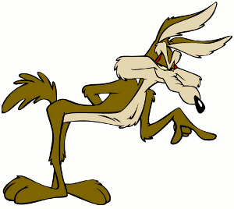Given Data:

Gravitational constant – 9.81 ms^-1

Weight of Anvil – 500 Lbs. (226.8 Kg)

I also needed the Weight of the Coyote in order to have enough data. Wikipedia reveals that the average weight is about 13.9 Kg.

The Segment from the show:

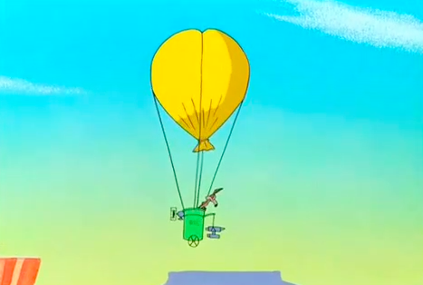

In the beginning of the Clip, the balloon is in complete Equilibrium (Not for long). Because of this, we know that the force of the balloon is equal to the force of gravity, and we have a net force of 0

FB = FG Net Force = FB - FG

The simplest way to find the force of the balloon is to calculate for gravity.

FG = ma

Using the standard gravitational constant, and the mass of both the Coyote and the anvil, the equation looks like this.

FG = (13.9 Kg + 226.8 Kg) * 9.81 ms^-2

Simplify

FG = (240.7 Kg) * 9.81 ms^-2

FG = 2361.27 Newton’s

Find Force of Balloon

Net Force = FB - FG

0 = FB – 2361.27 N

2361.27 N = FB

Now that I know the Force of the balloon, I can subtract the mass of the anvil and find the Net force to see how quickly the Coyote rises.

FG = ma

FG = 13.9 Kg * 9.81 ms^-2

FG = 136.36 N

Net Force = 2361.27 N - 136.36 N

Net Force = 2224.91 N

So the net force once the Anvil is dropped is over 2.2 kilo Newton’s. That doesn’t mean much when it comes to finding out how realistic that is, so I will find how fast the balloon takes off.

To do this, I shall simply work backwards from the Force Calculation

F = ma

F/m = a

224.91 N / 13.9 Kg = 16.03 ms^-2

Now that the acceleration of the balloon is found, I will try and see exactly how fast the Coyote is traveling upward in the 5 seconds that the clip lasts. To do this, I will use simple Kinematics

Velocity = v

Initial Velocity = u

Acceleration = a

Time – t

V = v0 + at

V = 0 + (16.03 ms^-2)(5 seconds)

V = 80.15 ms^-1

So at the end of the Coyotes wild upward climb, he was traveling at 80 meters per second, or about 180 Miles per hour. It is safe to assume from this data that the Coyote’s balloon rose way too fast. Dividing the velocity by the gravitational constant one can observe that the Coyote experienced a total of 8 G’s, which is known to make humans black out. This just further suggests that this event was not highly realistic, and that Wile E.’s failure to account for such rapid acceleration inevitably means that the Road Runner will get to live to see another day.

80.15 ms^-1 / 9.81 ms^-2 = 8.17 G’s

(Equation to find G-Force)

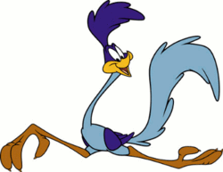

**Part 2:**

The Sonic Rainboom

For this last part, I will try to prove two things; I will prove using math that, once again, cartoon physics are not very realistic, and that My Little Pony is the coolest show out there.

“My Little Pony: Friendship is Magic” is a TV series started by Lauren Faust in 2010. It is based on Hasbro’s My Little Pony franchise that began all the way back in the 80s. The show in recent years has gained much interest, especially from a bizarre demographic: young, adult men. This is for a number of reasons, many of those reasons simply being because the show is awesome. Lauren Faust was the lead animator on many other popular TV series, including the Power Puff Girls and Fosters Home for Imaginary Friends. Her recent work on MLP has featured many different voice talents, such as Tara Strong, and has even had guest stars such as John De Lance, who was an actor on Star Trek: The Next Generation. Not to mention, the show is just plain awesome.

The show, as the title suggests, features a multitude of colorful ponies that explore the magic of friendship. So, what does this have to do with physics? One of the ponies, a Rainbow Pegasus appropriately named Rainbow Dash, is featured in the show as one of Ponyville’s greatest flyers. One of her signature moves, called ‘the Sonic Rainboom’, shows off both a sonic boom and an explosion of rainbow light. Because of the nature of such a stunt, it is safe to say that it is a physical impossibility. However, it does include the word ‘sonic’ in the name, and is descried as a type of sonic boom. A clip from the show even reveals the formation of what appears to be a Mach cone. Because of this, I decided to try and crack open the Sonic Rainboom, and find out just how fast Rainbow Dash is going to prove that she is, in fact, the Greatest flyer in Ponyville.

Calculations:

For this calculation, not much was given. However, a quick visit to NASA’s website revealed that I could calculate Rainbow Dash’s Mach speed from the angle of the cone using this equation.

Sin (θ) = Speed of Sound (a)/Velocity (v)

Using the Segment from the show, I was able to find that the angle was about 12º. I determined this by simply holding a protractor to the screen. After determining the angle, I was able to calculate Rainbow Dash’s velocity.

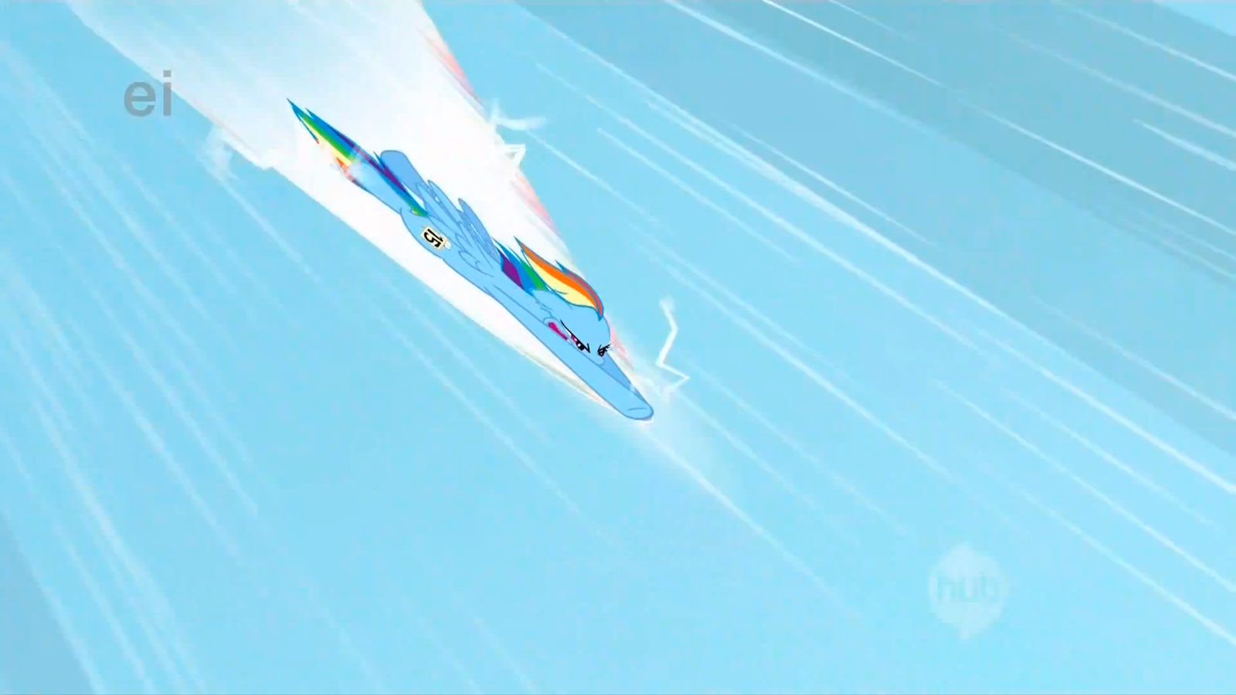

Sin (θ) = a/v

V = a/Sin (θ)

Sin-1 (12)(340ms^-1) = V

V = 1635 ms^-1

Now that I have found the velocity Rainbow Dash is flying at, I can calculate for acceleration and begin to find Forces and G-Forces to get an idea of how realistic her speed is.

I will use the standard formula to find acceleration from two velocities.

A =

A =

A = 109 ms^-2

With the value for acceleration, I can find the Mach number, Force, and G Force, and then I will be able to find out how realistic Rainbow Dash’s stunt is. For calculations for force, I used Wikipedia to find the average weight of an adult pony and found it to be 200 Kg.

Acceleration/Gravity = G’s

(109 ms^-2)/(9.81 ms^-2) = 11G’s of Force

Mach # = Velocity/Mach 1

M = 1635/340

M = 4.8

F = ma

11 G’s * 9.81 ms^-2 * 200 Kg = 21582 Newton’s

These calculations show that Rainbow Dash was experiencing 11 G’s of Force, and was exerting 21582 Newton’s. In real life standards, 11 G’s has been known to make vital organs fail in humans; While I’m not sure how many G’s an equine can handle, I think it is safe to assume that 11 G’s is equally deadly. The force she exerts from her dive is also equivalent to the total force exerted by a T-38 Talon. From this data, I can conclude what I sought to explain: Once again, cartoon physics prove to be unrealistic, and My Little Pony is awesome.

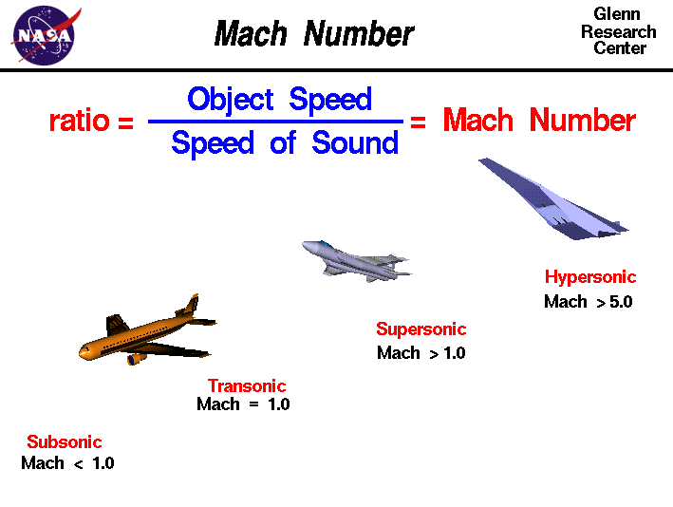

Attached is an image retrieved from NASA’s

Mach cone information page. Using what I knew about

Rainbow Dash’s Mach number,

I was able to mark her position on

the chart in relation to

other vehicles.

References

Balloon Lift Equations. (n.d.). *Balloon Lift Equations*. Retrieved from http://biotsavart.tripod.com/balloon.htm

Coyote. (2012, December 17). *Wikipedia*. Retrieved from http://en.wikipedia.org/wiki/Coyote

Hasbro (Producer). (2011, June 22). *Rainbow Dash's Sonic Rainboom* [Video]. Retrieved from https://www.youtube.com/watch?v=WImRs-nWW48

Mach Angle. (n.d.). *NASA.gov*. Retrieved from http://www.grc.nasa.gov/WWW/k-12/airplane/machang.html

*The Physics of Road Runner* [Video]. (n.d.). Retrieved November 18, 2012, from http://www.lghs.net/ourpages/users/dburns/RRPhysics/Road_Runner_Physics/Movie_files/BallonAnvil.mov

Pony. (2012, December 14). *Wikipedia*. Retrieved from http://en.wikipedia.org/wiki/Pony